Understanding the characteristics of fuel cells

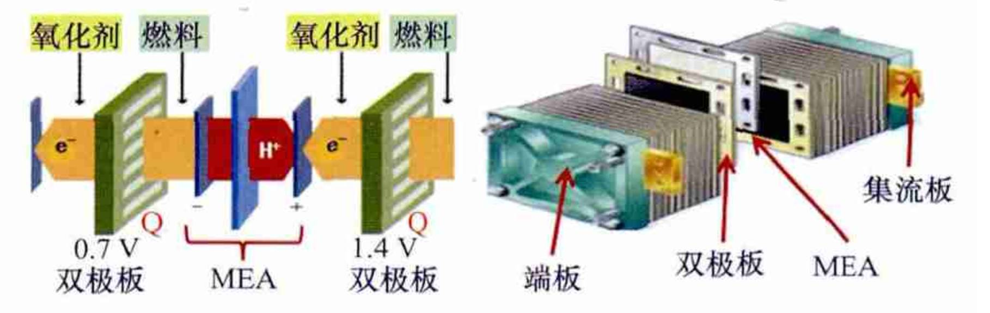
As the fourth type of power generation equipment， fuel cells have the following main advantages over other forms of power generation.
(1) The fuel cell converts chemical energy directly into electrical energy through the chemical reaction between the fuel and the oxidiser， with no intermediate energy conversion link. Therefore the energy conversion efficiency of this type of power generation can reach 50%. It is also possible to recover the waste heat generated during the power generation process. If the waste heat generated is reused for power generation， heating， water supply， etc. The overall efficiency can reach 80%.
(2) The fuel cell power generation process has few mechanical parts and low noise; the effluent from the chemical reaction is mainly clean gas such as water vapour， which will not pollute the environment. This advantage of fuel cells is particularly valuable today when environmental pollution is becoming increasingly serious.
(3) The fuel used in fuel cells can be natural gas， gas and liquefied fuel， but also methanol， biogas or even firewood. Depending on the specific situation in different regions， fuel cell power systems can choose different fuels， which can broaden the sources of fuel and alleviate energy shortages.
(4) From interruption to restart， the power transmission capacity of the fuel cell rises rapidly and the power output can be increased and decreased in a short period of time. It is therefore most advantageous to connect such a power generation system to other transmission networks， which can readily supplement some of the power needed during peak grid usage.
(5) The fuel cell itself is a "combination" and the components used can be produced in advance at the factory and then assembled; the small size and ease of disassembly can save time in building the power station.

