Application of on-site nitrogen generator in tire inflation field

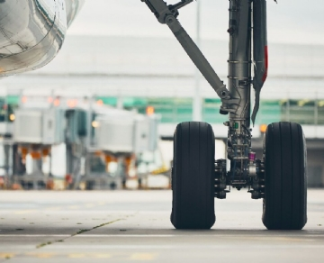
Nitrogen is widely used， especially in the field of tire inflation. Since nitrogen molecules are larger than oxygen molecules， inflating the tire with nitrogen can ensure that the tire maintains pressure for a longer time， because nitrogen molecules are more difficult to escape. This can increase fuel consumption， prolong the service life of tires and reduce downtime caused by tire problems.
Nitrogen is also an inert gas， which means that unlike oxygen， it will not have any adverse or dangerous effects on the tire itself. Nitrogen used for tire inflation can reduce the risk of oxidation， condensation and other forms of wear of tire lining， steel strip and rim.
Since transporting nitrogen is time-consuming and expensive， using an on-site nitrogen generator for tire inflation is the most effective way to generate nitrogen for your tire inflation needs.
Why is nitrogen used in heavy transport， off-road mining vehicles and aircraft tires
Nitrogen is usually used in heavy transportation， large off-road engineering vehicles， mining vehicles and aircraft tires because it can significantly improve the service life of tires and prevent explosion in case of tire burst.
In fact， NASA， the U.S. military， and the Indy and NASCAR teams have been using nitrogen for decades because nitrogen has been shown to maintain consistent tire pressure.
For example， off-road vehicles filled with air (oxygen) are prone to tire burst or fire due to excessive fracture and exposure to external elements. However， nitrogen is nonflammable and the flammability level is zero. Using a nitrogen generator to inflate off-road vehicle tires is a safer option.
The same applies to aircraft tires. It is important to optimize safety standards and operational efficiency as much as possible. Because nitrogen is not flammable， it is not only the preferred gas for inflating aircraft tires， but also the preferred gas for inflating aircraft slides and life rafts. Nitrogen provides a stable and inert atmosphere and prevents moisture from being trapped in the tire. The use of nitrogen generator can also minimize tire fire， tire fatigue and tire corrosion.
What are the benefits of on-site nitrogen generator for tire inflation?
Some benefits of installing on-site nitrogen generators (such as PSA nitrogen generator and membrane nitrogen generator) include:
Significant cost savings. Producing your own nitrogen means you don't have to pay the market price for cylinders or transportation costs.
Reduce the impact on the environment. Large transport trucks that consume a lot of fuel and often need to travel long distances are usually used to transport nitrogen tanks. The on-site nitrogen generator eliminates the need for delivery， thus reducing your carbon footprint.
Improve operational efficiency. When you need it， you will always have a stable nitrogen supply without the risk of depletion.
Eliminate operational downtime or delays. Sometimes， due to unforeseen circumstances， the delivery of nitrogen tanks may be delayed， resulting in serious operational delays. Producing your own nitrogen on site means that you will never be manipulated or arranged by another express company.

