1340m3/h membrane nitrogen generator for oil depot

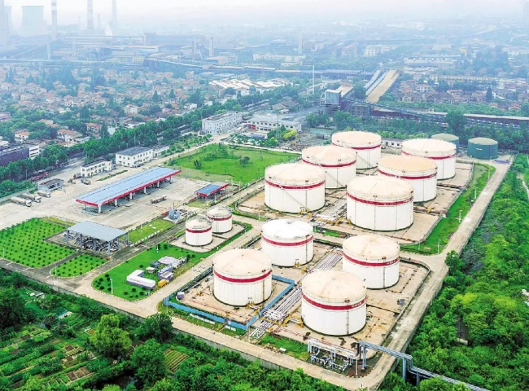
At a particular port， there is a large oil depot that stores various crude oils and other petroleum. This facility has most of the oil transportation pipeline network that goes directly from the ship to the storage tank. The storage tanks and pipelines are kept in a nitrogen environment and the pipelines are cleaned after each transfer.
This requires large amounts of nitrogen at pressures of 7-10 bar.
For this Seagate supplied a 1340 m3/h membrane nitrogen generator.
This is a very compact containerized unit. The membrane technology is superior and more economical than PSA technology and can produce low nitrogen with a purity of 95-99.9%. Furthermore， by using high pressure compressed air directly， the membrane nitrogen is produced at a pressure of 12 bar without the need for a nitrogen booster.
This gas plant is equipped with air-cooled screw compressors from KAESER， Germany. The German made air-cooled screw compressor is suitable for high ambient temperature conditions.
The entire nitrogen generator plant is controlled by a PLC， the nitrogen purity is continuously monitored and the gas unit is continuously switched on and off according to the customer's nitrogen demand.
No operator is required. This gas generator has been in operation for a considerable period of time and has performed very satisfactorily.
About Membrane Nitrogen Generators
Membrane nitrogen generators have many benefits over other technologies， such as low maintenance and very low production costs.

