Laser cutting with nitrogen in the industrial sector

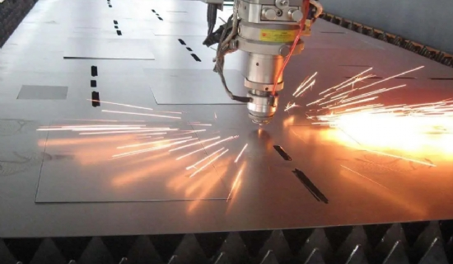
Nitrogen is an inert gas that has many uses due to its unique properties. Its inertness proves useful when driving laser cutting machines because it does not oxidize when in contact with the surrounding air. The laser beam in a nitrogen medium is also purer and more enhanced because nitrogen is a dry and clean gas.
Hitt supplies a nitrogen generator that produces pure nitrogen for laser cutting. It worked with a German company to apply modern PSA technology to design this gas generator.
Advantages of installing a nitrogen generator for laser cutting
While oxygen is often used as an auxiliary gas when cutting metal， nitrogen has many additional advantages. Here are the top reasons to use a nitrogen generator for precision laser cutting
Cost-effective
With the help of a nitrogen generator， the cost of nitrogen production is quite low. It costs almost nothing to run this gas generator， and for this reason， laser cutting becomes a low-cost operation.
Mass production
XITE's gas generators have the capacity to produce large quantities of nitrogen. As a result， nitrogen for laser cutting is more readily available whenever it is needed by industry.
Pure Nitrogen
PSA nitrogen generators produce 99.99% pure nitrogen， which forms the optimum medium for laser cutting. Since nitrogen does not interact with other gases， it remains pure when transferred to the customer's production site for use.
Uninterrupted production
Since the nitrogen generator can work without interruption， it can supply nitrogen 24 hours a day if required. Therefore， there is no nitrogen shortage for industrial applications of laser beams.
Easy operation
XITE offers a compact gas generator that does not require any additional equipment for its operation. The user only needs to turn it on and start receiving nitrogen for laser cutting within a few minutes.

