Sustainable shrimp farming

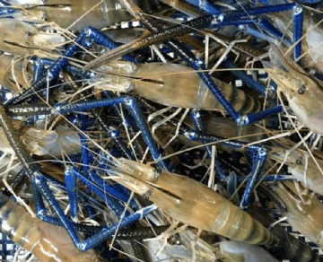
Shrimp farming provides a tremendous opportunity for economic and social uplift for rural communities in the coastal areas of the country. More than 100，000 farmers， about 90% of whom fall into the small and marginal category， are taking advantage of this opportunity to earn a living. However， sporadic disease outbreaks， lack of technical skills and scientific application， high quality inputs (e.g.， seeds)， limited access to series， and difficulties in meeting market requirements are forcing the need to adopt means to practice shrimp farming in an environmentally， socially， and economically sustainable manner. Therefore， the adoption of appropriate shrimp health management practices is a first step in this direction.
In this context， the National Center for Sustainable Aquaculture was established as an outreach organization of MPEDA to build capacity among small-scale shrimp farmers and to address shrimp health and quality management issues. The National Center for Sustainable Aquaculture is establishing an association of shrimp farmers and promoting best management practices among them to achieve sustainable aquaculture and ultimately strengthen our nation's economy.
Key aspects of sustainable shrimp farming.
The goal is to produce shrimp in a responsible and sustainable manner while minimizing risks and maximizing returns.
This goal will be achieved by
- Organizing an association of aquaculturists to carry out all farming activities in a disciplined and cooperative manner.
- Design and construction of ponds in appropriate locations
- Developing basic infrastructure
- Developing a crop calendar to coordinate all farming activities in the cluster
- Adopting better management practices.

