Oxygenation in aquaculture

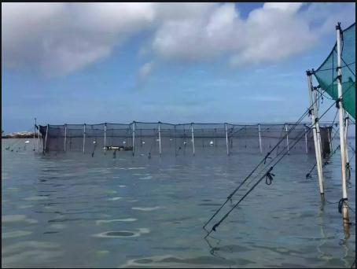
No organism can survive without oxygen， and this is also true of aquatic species. In aquaculture， oxygen is very important for the growth of healthy fish and shrimp， and it is important that aquatic species receive sufficient oxygen in the pond in order to reduce fish losses.
How oxygen is supplied to ponds.
We all know that oxygen from the atmosphere enters the pond and that the water absorbs oxygen from plants， but this cannot be sufficient at all times. As a result， with the development of aquaculture， aquaculturists have also started to use artificial oxygen to aquatic species in their ponds.
Oxygen consumption of fish.
The oxygen consumption of fish also varies from species to species. A few fish require more or sufficient oxygen and small reductions in oxygen can lead to losses. Few fish require oxygen and can tolerate and maintain declining oxygen levels.
The main objective of aquaculturists is high stocking densities at low water consumption， which can only be achieved with an adequate supply of oxygen.
Recently， most aquaculturists have relied on artificial means of supplying oxygen to their ponds， as the addition of dissolved oxygen to the farm water provides sufficient oxygen at peak times to promote fish growth and profitability. An ideal 70-80% dissolved oxygen in the water will give ideal yields.
Benefits of artificial oxygenation :
Purifies the water of toxic gases
Cleans the pond bottom and absorbs suspended bacteria and dirt
Helps and increases the supply of dissolved oxygen in the pond
Regulates pH fluctuations
Destroys pathogens
Helps to improve the growth rate and sustainability of species
Dosage
The dosage and application of oxygen cakes varies from pond to pond. Various factors are taken into account when applying， such as pond size， water quality， species type， growth rate and number of species. Most farmers will follow the advice of expert technicians.
It is recommended that oxygen cakes are spread evenly over the bottom of the pond at night to compensate for the lack of oxygen supply that generally occurs in the morning.
These artificial oxygen products have become a lifesaver for aquaculturists. With all this progress， we will soon see the correct supply and correct demand for aquatic products.

Translated with www.DeepL.com/Translator (free version)

