Is nitrogen effective in preventing flat tyres?

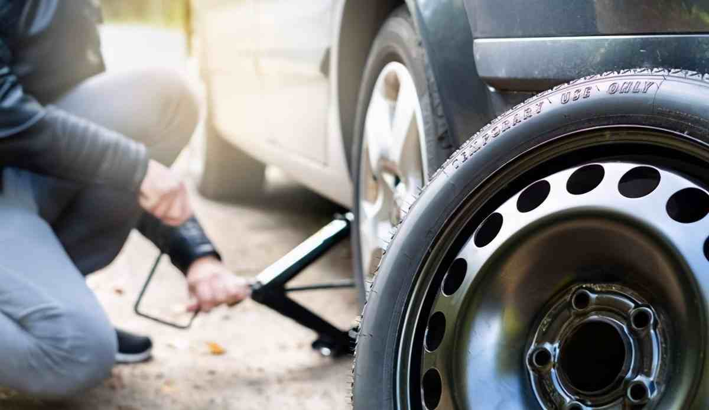
Can nitrogen effectively prevent flat tyres?
1， if the tyre is not enough air pressure: the general speed of the car is very fast， the shape of the tyre is in a high-frequency alternating state， if the air pressure is not enough to increase the deformation of the tread on both sides of the tread pattern will be excessive wear and tear， the carcass is unable to resist the pressure of the ground and the distortion and deformation， resulting in high temperatures to accelerate tyre wear and tear， which leads to a flat tyre.
2， if the tyre pressure is too large: if the air pressure is too large will also make the tyre too hard to lose the elasticity and shock-absorbing capacity， not only the grip becomes poor， excessive wear of the tread pattern will produce uneven depth of the phenomenon of tyre， tyres at high speed may not be able to withstand excessive expansion of the pressure and the occurrence of a flat tyre.
So the tyre pressure is too high or too low have the danger of flat tyre， do not underestimate the air pressure problem. The standard air pressure of tyres， including the spare tyre， should be maintained in accordance with the manufacturer's requirements. Tyre pressure can be measured by tyre pressure monitoring， but it needs to be measured in the state of normal temperature of the tyre， because the results measured in the state of hot tyres are inaccurate.
Why fill with nitrogen? Nitrogen belongs to the inert gas， dry nitrogen in the temperature change， the volume expansion is far lower than the air containing water， so when the tyre warms up at high speeds， the tyre pressure rises less， reducing the chance of a flat tyre. In addition， as nitrogen contains no water， it protects the inside of the rim from oxidation， thus effectively extending the life of the tyre.

