Cost control of iron and Steel Metallurgical Industry
Steel industry and cost control

Production cost is a fundamental indicator of organizational performance. It determines how effectively an organization works. It has a very strong impact on the profitability and bottom line of the organization.

Control is an activity that verifies that established objectives are being achieved as planned. Control activities are carried out by monitoring and analyzing data related to activities. The monitoring and analysis of data indicates whether facts or events have occurred as specified in advance by those responsible. Monitoring and analysis activities also identify deviations between what is proposed to be achieved and what has been achieved， and determine the causes of the deviations so that those responsible for the activity can take appropriate decisions to take corrective measures to eliminate them. This helps to prevent greater deviations from occurring in the future if corrective measures are not taken in a timely manner. In other words， through control， negative factors are identified so that they can be gradually eliminated to ensure the healthy continuation of the activity.

Cost control in an organization is accomplished by conducting a cost analysis， which identifies opportunities for improving the parameters of the production process and the product (design and quality). The cost control process in the organization (Figure 1) represents all decisions made regularly by providing analytical data to managers and other cost owners. Data about deviations are determined by comparing actual costs (realized) and planned costs (standard) with the aim of taking some corrective actions through appropriate decisions of management in order to control the production costs of the product. Cost control is part of the administrative control exercised by the organization's management to manage the organization.

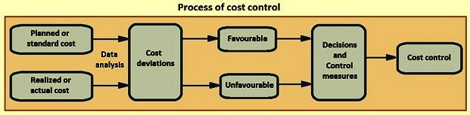
Figure 1 The process of cost control

The process of cost control is carried out by preparing a cost sheet. Detailed cost sheets and cost variance analysis are prepared for each operational step in the production of marketable products. Cost sheets are prepared on a scientific basis， so they accurately reflect areas where corrective action is needed to effectively control costs. Cost sheets are usually prepared on a regular basis， for example， monthly based on data from the previous month. Annual cost sheets are prepared based on annual data. Standard cost parameters are usually those on which the monthly/annual budget is based. Figure 2 shows the cost variance analysis model.

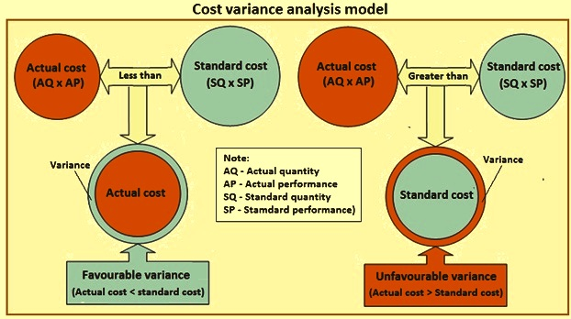
Figure 2 Cost variance analysis model

The two components of production costs are (i) variable costs， and (ii) fixed costs. Variable costs are those costs that vary according to the volume of production. These costs rise as production volume increases and fall as production volume decreases. Variable costs are different from fixed costs， which remain constant regardless of production volume.

The main components of variable costs are (i) raw material costs (primary and auxiliary materials)， (ii) energy costs (fuel and electricity)， (iii) utility costs (industrial gases， water and compressed air， etc.)， and (iv) maintenance costs (spare parts， consumables such as lubricants， grease， etc.). (v) cost of refractory materials， (vi) cost of operational modifiable factors (rolls， guides， shear blades， etc.)， (vii) labor costs (conventional and contractual)， and (viii) operational management costs. The components of fixed costs are (i) depreciation， (ii) interest on fixed capital， (iii) interest on working capital， and (iv) organizational overhead.

Specific variable costs (variable costs/unit of product) depend on the efficiency of operating performance and do not actually depend on the volume of production. On the other hand， specific fixed costs (fixed costs/unit of product) depend to a large extent on the volume of production. That is， the higher the production volume， the lower the fixed cost component of the product cost.

The cost control process in a steel mill is a multivariate system that is subject to a large number of interacting variables that affect the cost performance of the steel mill. It is necessary to isolate the interactions of these variables in order to understand the role of each variable on the cost performance of a steel mill. The main variables that affect the cost performance of a steel mill are discussed below.

Productivity - It is the specific rate of production. It is usually given in terms of units of volume， units of area of the furnace or units of time. The higher the productivity per unit of a steel mill， the lower the cost of production. Higher productivity leads to better utilization of the plant and equipment.

Throughput - Throughput is the actual output of a unit. For good cost control， it is necessary to run each unit of the steel plant to its maximum capacity. When a unit's output is below its capacity， the specific level of consumption increases. In addition， when a unit is underutilized， a higher portion of fixed costs (headroom， depreciation， interest， etc.) is loaded onto the product output of each unit. In addition， the capacity of each subsequent unit needs to match that of the previous unit so that there is no underutilization of any unit.

Raw Materials - In today's scenario， raw materials are the main cost of production. Therefore， the specific consumption of raw materials should not exceed the technical requirements of the process. Any waste of raw materials and deterioration during storage should be completely avoided. Moreover， the quality of raw materials plays a very important role in cost control. Low quality raw material， although less expensive per ton， leads to an increase in its own consumption and that of other raw materials. It also increases the heat demand of the furnace， leading to an increase in fuel and energy consumption. This has a significant impact on the specific cost of the product.

Fuel - All metallurgical processes in steel plants take place at high temperatures， so they are fuel-intensive. In addition， the cost of fuel is always increasing. Therefore， the specific consumption of fuel needs to be kept within the limits required by the technology employed. It is necessary for management to prioritize technological upgrades in this area in order to reduce the specific consumption of fuel. The payback period for such upgrades is usually very short， which justifies the capital expenditure for such modifications. Therefore， these retrofits should be undertaken without hesitation.

Energy - In addition to fuel， steel plants use other forms of energy. Among these energy sources， electrical energy contributes significantly to production costs. The quality of the electrical energy (power factor) is very important because it contributes significantly to the energy consumption and therefore to the cost. In order to reduce the power consumption， the correct motor rating is required. The no-load operation of the motor also has to be controlled. Where feasible， further modifications are required to switch to hydraulic and variable frequency drive motors to reduce specific power consumption. Another area that typically has great potential for power savings is in the area of shop lighting.

Utilities - Included under the category of utilities are industrial gases (such as oxygen， nitrogen， argon， etc.)， acetylene gas， compressed air， steam， and water. This is an area where cost control steps are very effective. Often overlooked are pipeline leaks of airborne utility gases， which need to be controlled through regular inspection and maintenance， as these leaks have a considerable impact on production costs.

Labor - In some developing countries， labor costs are still perceived to be low， so there is often a preference for labor-intensive technologies because the capital costs of these technologies are usually low. Factories built under this philosophy fall into the trap of rising production costs after a while. In addition， the high reliance on human labor means that there is a greater likelihood of human-related errors and， therefore， lower reliability of processes and equipment. In addition， in the case of labor-intensive technologies， labor motivation is very important to output. Any decrease in motivation means a decrease in output， which leads to an increase in costs. Investments in the level of factory automation can contribute significantly to cost reduction. Investments in automation also typically have a low payback period.

Maintenance - Planned preventive maintenance of plant and equipment ensures high plant and equipment availability in production. When timely and proper maintenance of plant and equipment is neglected， there is usually a high level of equipment failure. This leads to unscheduled process disturbances. Process disruptions can lead to lower yields or product quality fluctuations or both. This has a significant impact on costs. Therefore， saving on maintenance costs is always counterproductive and should not be done if it is to reduce overall costs.

Inventory - Inventory is a double-edged sword as far as costs are concerned. Large inventories mean clogging up working capital， and interest on those funds adds to costs. On the other hand， if a process is stopped due to the unavailability of raw materials， intermediate products， utilities， consumables or spare parts， there is a process disruption in addition to a drop in production. This has an impact on costs， which usually increase. Therefore， inventory should be kept at an optimal level based on actual consumption in previous years to reduce the impact on costs.

Technology - Technology is another area that requires the most attention if production costs are to be kept low. All those technologies that reduce consumption of raw materials， fuels， energy and utilities and improve product quality should be selected for adoption， even if they have a higher capital cost. The increase in capital costs is usually compensated for in a short period of time， but the advantages gained through reduced consumption and improved product quality are usually maintained over the life of the plant.

Waste recycling - Most processes in a steel plant generate large amounts of solid (dust， sludge， scale， scrap， slag， etc.) or liquid waste. These wastes， if recycled， can reduce the consumption of raw materials， fuel and water. The payback period required to recycle these wastes is very short. Therefore， these investments will be prioritized in order to effectively control costs.

Recovery of waste energy - The recovery of waste energy contributes significantly to cost reduction. The exhaust gases from the process are usually very hot and contain a lot of thermal energy. This energy can also be in the form of chemical energy. Releasing these exhaust gases into the air is similar to throwing valuables into a river. Recycling these exhaust gases reduces fuel consumption and therefore not only reduces specific energy consumption， but also reduces carbon dioxide emissions， which is a greenhouse gas.

Product mix - Steel mills need to have a product mix that maximizes profits. The tendency to sell higher intermediate products has to be resisted and therefore a higher sales volume is necessary. The production and sales of finished products will be maximized because it covers greater fixed costs. Here the importance of forward integration comes into play. The production of further value-added products needs to be optimized， as they can be produced at a small additional cost in an integrated steel plant.

Process control and quality control - Effective process control and quality control are very important for cost management in a steel mill. These controls can help in cost management by increasing product yields and reducing the production of scrap， rejects and material that is converted to lower grades.

Pollution control measures - Some steel mill management believes that pollution control equipment is a cost burden because they require not only investment， but also electricity and consumables to operate. However， this belief is not based on hard facts. Pollution control equipment recovers large amounts of dust， sludge， scale， etc.， which when recovered can save a great deal of raw material. Without pollution control measures， not only would these materials be permanently lost， but they would also cause serious pollution to the environment.

Safety - Safe working of processes and equipment helps in cost management. Unsafe work can lead to process disruptions， equipment failures and operator injuries. This in turn means lost production and increased costs. In addition， any injuries to staff can reduce employee morale and efficiency， which can again lead to lost production.

In addition to the above， there are three basic rules regarding cost， namely (i) cost of quality (ii) tip of the iceberg and (iii) the 1-10-100 rule， which must be followed when making important decisions regarding cost. These rules help steel mills to cut costs without affecting their long-term capacity.

