How can the nitrogen production equipment last longer

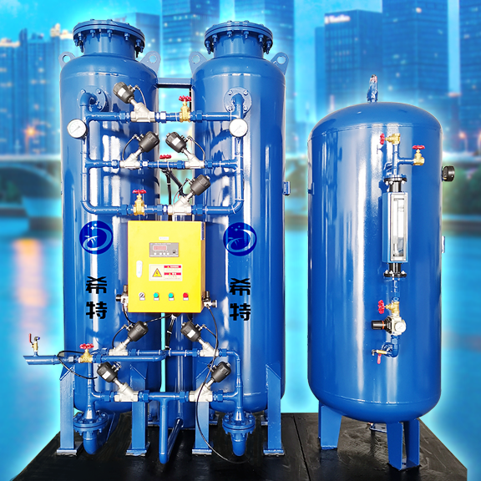
Aujourd'hui， l'équipement de production d'azote a été largement utilisé dans l'industrie sociale. L'utilisation à long terme de l'équipement de production d'azote dans de nombreuses industries peut causer des problèmes， de sorte que l'entretien est nécessaire à ce moment - là. Ainsi， plusieurs fois affecteront le temps d'utilisation de l'équipement de production d'azote. Comment prolonger le temps d'utilisation de l'équipement de production d'azote? Voici une brève introduction de l'équipement de production d'azote pour les utilisateurs， dans l'espoir d'aider tout le monde.

At present， nitrogen making equipment has been widely used in social industries. If nitrogen making equipment is used for a long time in many industries， it will break down. At this time， it needs to be repaired. In this way， the use time of nitrogen making equipment will be affected for several times. So how to prolong the use time of nitrogen making equipment? The following brief introduction of nitrogen making equipment will be given to the majority of users. I hope I can help you.
The equipment used with the nitrogen making equipment， that is， the dryer used with the nitrogen making equipment， such as freezing dryer and adsorption dryer， shall be checked at any time to see whether it can work and operate normally. And its operation shall be carried out in accordance with the provisions in the product operation manual， so as not to affect the nitrogen production effect of the nitrogen production equipment.
The purity， gas production and other performance indicators of nitrogen production equipment shall be checked frequently， as well as the supporting oxygen meter of nitrogen production equipment. Whether it can be used normally and whether there are abnormalities shall be checked. If there are problems， they shall be handled and solved in time.
If the filter is to be used in the nitrogen production equipment， the filter should be checked， mainly to see whether the filtering accuracy of the filter meets the use requirements. And whether the filter element in the filter can be used normally and whether it needs to be replaced. In addition， the special carbon molecular sieve in the nitrogen generator equipment should also be noted. If it is aged or powdered， it cannot be used anymore， and a new special carbon molecular sieve should be used.

