Application of nitrogen in bright annealing of copper and copper-nickel alloys

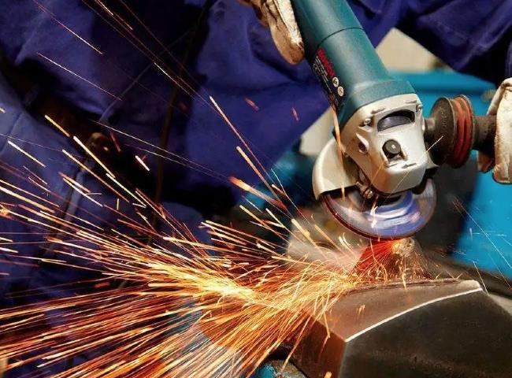
PSA nitrogen generator， nitrogen generator， nitrogen gas
Suzhou XITE has installed a 75Nm3/Hr nitrogen generator with 99.5% purity and 6KG/CM2 working pressure for annealing furnace Suzhou XITE is a leading designer， manufacturer and supplier of PSA nitrogen generators. Nitrogen is widely used for seamless extruded copper， copper alloy products， copper-nickel alloy， aluminum brass， and Admiralty brass.
The annealing technique of Hitter Nitrogen generators is to heat to and maintain at a suitable temperature and then cool at a suitable rate to reduce hardness， improve machinability， promote cold working， produce a desirable microstructure or obtain desirable mechanical， physical or other properties.
Seagate annealing can be performed in a variety of different furnace atmospheres， depending on the material involved， including combustion products， nitrogen， nitrogen/hydrogen mixtures， exothermic and heat-trapping gases， dissociated ammonia (or dissociated ammonia diluted with nitrogen)， hydrogen， and vacuum.
Other generic names and related topics are listed below.
Isothermal annealing
Subcritical annealing
Process annealing
Softening stabilization
Recrystallization annealing
Spheroid annealing

