5 advantages of using oxygen generators for water treatment

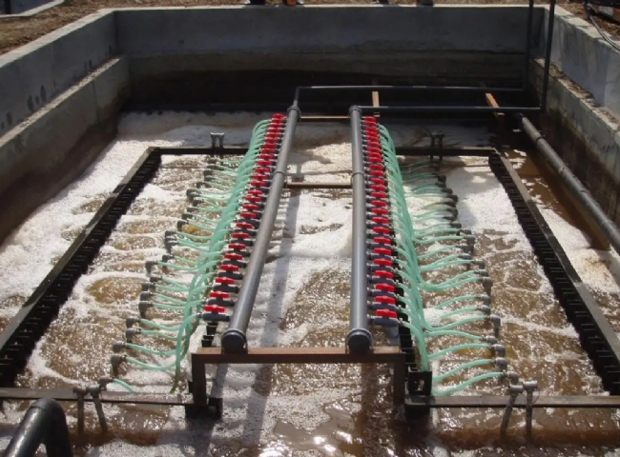
Nothing is more important to the life of every living thing on this planet than water. Access to clean water is a stepping stone to development. If people have access to clean water， they will be able to practice good sanitation and hygiene. However， access to clean water is becoming more difficult every day due to the increasing consumption of water worldwide. People are going to great lengths to obtain the quality and quantity of water they need to cook， drink， bathe， wash and grow food.
To get clean water， water oxygenation is the best treatment. Injecting oxygen into your water system can amplify the impact by removing impurities and contaminants from your water supply.
How does an oxygenator help recycle wastewater?
Making wastewater reusable is a time-consuming process because the water needs to be biodegraded. Since biodegradation takes place with the help of bacteria， there is a foul odor and harmful chemical gases such as methane gas and hydrogen sulfide are produced. To avoid the pungent odor and harmful chemicals， using oxygen to feed the bacteria is the highest strategy.
5 advantages of using oxygen generators for water treatment
Apart from avoiding bad odors and unsafe gases， oxygen generators have some other advantages as well. The advantages mentioned below will demonstrate why water oxygenation is the best.
1. You can avoid high sewage treatment fees - Just as there is a charge for consuming clean water， there is also a charge for wasting water. Treating wastewater increases the cost to the consumer. Getting an oxygen generator is a wise decision for everyone who wants to reduce the cost of wastewater treatment because of the low cost and output of the generator.
2. Affordable - Having an oxygen generator is self-sufficient because it frees the user from never-ending bills and the worry of obtaining oxygen produced at low temperatures. These generators require low energy， resulting in low cost.
3. Zero Maintenance - XITE oxygen generators can be maintained without any technical expertise or complex training. In addition， there is virtually no need to repair the machine.
4、Produce high purity gas - XITE on-site oxygen generators produce oxygen with a purity higher than 95%.
5、Very easy to use and fast - Compared to other methods， the practice of oxygenation of water bodies is not complicated and fast.
To get the perfect water treatment system for your needs， please send your inquiry and we will tell you about our oxygenator options.

