Industrial oxygen generators in cutting and welding applications

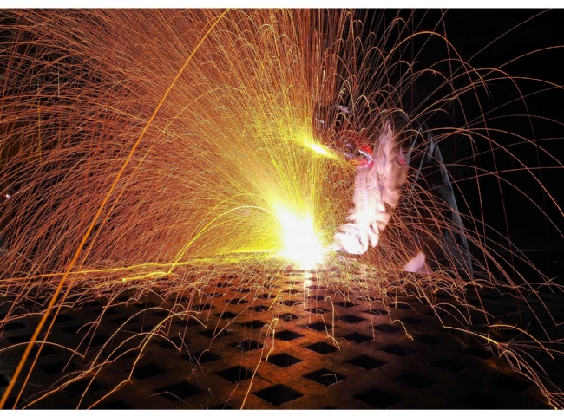
Oxyfuel combustion is a fuel combustion process that uses pure oxygen rather than air as the primary oxidizer. If the nitrogen component of the air is not heated， less fuel is consumed， which makes higher flame temperatures possible.
Historically， the primary use of oxyfuel combustion has been for welding and cutting metals， especially steel， because oxyfuel combustion provides higher flame temperatures than ordinary air fuels.
Oxyfuel welding (commonly referred to worldwide as oxyacetylene welding， oxyfuel welding or gas welding) and oxyfuel cutting is a process that uses a fuel gas (or liquid fuel， such as gasoline) and oxygen to weld or cut metal.
In oxy-fuel welding， a welding torch is used to weld the metal. When two parts of metal are heated to the same temperature， there is a shared pool of molten metal and the metals can then be well welded together. The molten pool is generally referred to as a filler along with the other metal. The use of filler depends on the metal to be welded.
In oxy-fuel cutting， a torch is used to heat the metal to its combustion temperature. The oxygen stream is then trained on the metal， burning it to metal oxide， which flows out of the cut as slag.
Advantages of oxyacetylene welding/cutting
Oxyacetylene welding is easy to get started
Most welders need to have a tool on hand to cut metal， and an oxyacetylene torch is an affordable way to kill two birds with one stone. By setting up a torch for welding， you can add a filler rod， or simply rely on the heat of the process to join the metal. Best of all， torch welding setups can help you with a variety of projects: welding， heating， brazing and bending. You can work with carbon steel， chromium-molybdenum steel， aluminum， stainless steel， and even cast iron. It's not a bad range of options!
Welding portability and heat
The oxyacetylene welding process is especially convenient when you need to turn up the heat. While multi-process welders and electrode machines are lighter in weight and more powerful， oxyacetylene welding has historically been the welder's first choice. The simple setup allows welding anywhere.
Welding leaky cars and machines
Regular users of oxyacetylene welding appreciate its effectiveness in welding oil-soaked cars and trucks inside crankcase and transmission housings. While arc welding attracts more heat to the surface and contaminates the weld， oxyacetylene will join the metal more effectively without applying too much heat to the weld. This will minimize the amount of oil in the weld itself.
Of course， many automotive welding jobs require heating and bending of the metal， so a single torch setup can serve both heating and welding purposes in the same project.
With Suzhou Xite's on-site PSA oxygen generators， your real-time oxygen supply for cutting or welding at the customer's site will be guaranteed at all times.

