The role of aerators in aquaculture

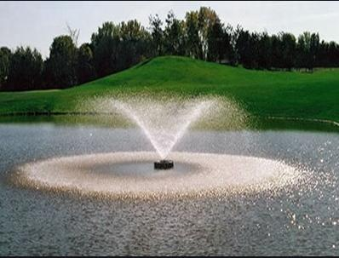
Aerators are various devices used to aerate， or mix air with another substance， such as soil or water. These devices are used to add oxygen to the water. Aeration brings water and air into close contact to remove dissolved gases (such as carbon dioxide) and to oxidise dissolved metals such as iron， hydrogen sulphide and volatile organic chemicals.
Aquaculturists aim to achieve yield and profit and profitability by minimising risk. Aerators provide the most direct and rapid solution to QM and hypoxia. In aquaculture， each species has been accustomed to different living conditions during its evolution. Species living in fast flowing and oxygen rich rivers require large amounts of oxygen and small changes or reductions in dissolved oxygen can lead to the complete loss of the species. Aeration removes chemicals that affect aquaculture ponds， such as ammonia， chlorine， carbon dioxide， methane， hydrogen sulphide， iron and manganese.
The main purpose of an aerator is to provide oxygen and mixing so that oxygen is dispersed throughout the pond. A very important factor to consider when choosing an aerator is the dispersion of oxygen. It involves subsurface circulation and oxygenation to create a de-aerated pond environment. This concept is very important as it leads to increased size， improved survival rates and increased profits. For species like shrimp that live on the bottom of the pond， the distribution of oxygen to the pond floor is a must. The mixing and distribution of oxygen reduces the waste of feed and leaves the pond bottom clean and free from the risk of disease.
We have different types of aerators such as air jets， water circulators， combination aerators， splash aerators and submersible aerators. Despite the wide range of aerators available， it is always important to choose the best aerator for your requirements. Recently， the most commonly used aerator has been the paddle aerator. We also have things like 1HP 2 paddlewheel aerators， 1HP 4 paddlewheel aerators， 2HP 4 paddlewheel aerators， 2.5HP 6 paddlewheel aerators etc. We need to choose according to our requirements. Aerators play a key role in the low oxygen levels in a pond， mixing the water by providing better water quality management. We can view and purchase different types of aerators at Aquadeals.
General features for aquatic farmers to look for when purchasing an aerator
Low noise operation
Long working life
Low maintenance costs
Impact resistant
Light weight
Easy to replace and install
Higher oxygen transfer capacity
Stainless steel frame.
Mechanical seal to prevent oil leakage
Robust construction
Durable and long-lasting
Flawless
As the aquaculture industry grows， so does aquaculture machinery. Aerators using the latest technology are extremely efficient and easy to use. Now we have highly efficient electric motors and low energy consumption aerators， which are the preferred choice of all farmers. Whereas earlier farmers faced the challenge of obtaining spare parts for their aerators， now even spare parts are easily available from manufacturers and online.

Translated with www.DeepL.com/Translator (free version)

