Benefits of using nitrogen in tires

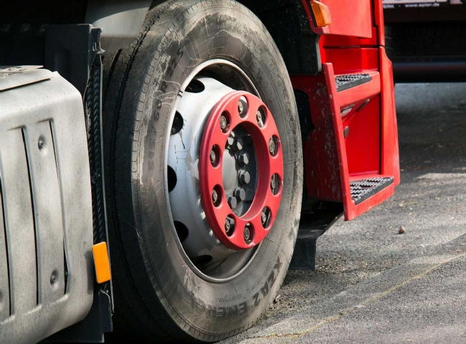
One of the lesser known uses of nitrogen is its use in commercial and personal vehicle tires. Tires are an important part of the vehicles we use for transportation and it is vital that they are maintained to ensure proper safety. Nitrogen has different properties that make it an ideal gas to use in tires. Next we look at how nitrogen works and the benefits it offers.
Inputs and outputs
There are benefits to using nitrogen in tires for commercial and industrial vehicles. For example， aircraft tires are filled with nitrogen because it is an inert gas， which means it can withstand higher temperatures than air-filled tires. Aircraft take off and land at speeds of about 150-200 mph， generating a lot of heat from friction with the runway. In an emergency landing， the nitrogen in the tires helps prevent the tires and wheels from catching fire on the runway due to overheating. Surprisingly， aircraft tires are not very large， but they are very durable. The nitrogen maximizes air pressure， giving them extra strength to hold the weight of the aircraft.
Racing cars too! Nitrogen is used in race cars because they require a lot of wear and tear and need to have durable tires that can withstand the heat during long races. Even small changes in tire pressure can be a big problem for racers at high speeds. Nitrogen allows tire pressure to remain constant throughout the race， while regular pneumatic tires cannot handle such fluctuating temperature extremes.

At H&T， we fill all delivery truck tires with nitrogen. It is well known that trucking companies use nitrogen in their fleet tires for economic reasons. Tire pressure is more consistent over longer periods of time， which reduces the frequency of checking tire pressure. Because fleet trucks travel long distances for long periods of time， and often across the country， flat tires are very common. Using nitrogen in their tires reduces the chance of tire burnouts， streamlines truck routes and reduces costs for fleet companies.

Personal Use and Benefits
People typically check their tires at gas stations and use free air to supplement their tires when they fall below the ideal air pressure. Air is made up of about 80% nitrogen， 20% oxygen and very small amounts of other gases such as carbon dioxide， helium and water vapor. Many people do not know that nitrogen can be used as a substitute for air and has additional benefits.
Nitrogen in your tires will help keep your tire pressure stable. Oxygen in an air-filled tire will slowly escape through the tire walls over time. Nitrogen-filled tires are much less likely to escape. Keeping your tire pressure at optimal levels will reduce your fuel costs and keep your tires in excellent condition while extending the life of your tires.
Moisture and water vapor in your tires can cause pressure changes as tire temperatures change with driving and weather conditions. Nitrogen is a dry gas that， when properly added to a tire， repels water vapor and oxygen， so there is less chance of moisture inside.
Many tire and auto stores are now equipped to dispense nitrogen to tires. If your business is ready to start providing tire nitrogen， H&T can provide advice on how much nitrogen you need.

