How to keep the feed in shrimp culture?

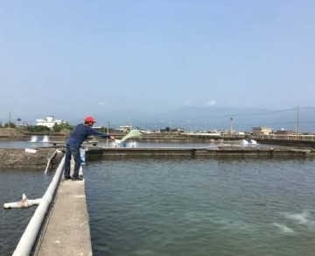
Feed management is one of the most important aspects of successful shrimp farming， as feed accounts for 50-60% of operating costs.
Key instructions for feed management：
- Check the date of manufacture on the feed bag when the feed arrives. The date of manufacture of the feed should not be more than 90 days old. Begin feeding on the day the seeds are released. The initial feed should be mixed with a small amount of water to facilitate distribution and to ensure it sinks quickly. Determine the size of the pellet according to the size of the shrimp. Mix two feed sizes for at least 4 days while switching from one feed size to the other. The daily feeding should not exceed the amount in the feed table provided with the feed bag. Weigh and record the exact amount of feed required in the pond log book.
- Reduce feeding during periods of low dissolved oxygen， plankton collapse， rainfall， molting， extreme temperatures， and disease outbreaks. Shrimp actively swimming at the edge of the pond (but not at the surface) during daylight hours may indicate underfeeding. If you observe this after 10 days of stocking， monitor feeding for 20 days. conduct regular weekly sampling of shrimp after 45 days to determine growth rate and calculate FCR. do not overfeed. Do not mix any antibiotics in the feed. As long as the feed is fresh and of good quality， there is no need to mix any additives into the feed.
- During the first 10 days of breeding， feed should be spread within 2 to 4 meters from the edge of the pond. Use a spoon to distribute the feed widely. After the first 10 days， shrimp enter the main part of the pond. Use a boat/floating device to spread feed throughout the pond; do not spread only on the edge of the pond and in shallow water. Check the soil at the bottom of the pond regularly and avoid feeding in areas and corners where there is black and foul-smelling soil.
- Feed should be supplied to clean areas in the pond. In ponds with aerators， feed in areas that have been cleaned by water movement. It is best to turn off the aerator before feeding until 2 hours after feeding， depending on the stocking density. If an automatic feeding transfer has been arranged， the stored feed needs to be verified and the time adjusted according to the observations of the check tray.
- Use feed trays to monitor feeding. Use 4 to 6 best stainless steel feed trays (round， 80 cm diameter) per hectare of pond to monitor feed consumption of shrimp after 30 days. Feed trays should be placed at the bottom of the pond， 2 m away from the slope of the pond dam， aerators， sluices and pond corners. Offer feed in the feed tray and check it according to the feed table below. Record the quantity， brand and lot number of feed in the pond log book. Place the inspection tray slowly into the water to prevent the feed from scattering. Make sure the check tray settles to the bottom of the pond. If more than 25% of the feed is left on the tray， suspend the next feeding; if 10-25% of the feed is left on the tray， reduce the feed by 50% at the next feeding; if less than 10% of the feed is left on the tray， continue feeding as scheduled; if no feed is found to be left on the tray， add about 5% of the feed at the next feeding.
- In addition to survival， there are several factors that can affect feed consumption in the tray. Check when you notice a decrease in feed consumption - water quality and pond bottom deterioration
- Competitors in the pond
- Quality of feed
- Moult cycle
- Temperature， salinity and rainfall
- Diseases
If consumption drops sharply and does not improve within two to three days， then check for health problems. Keep the inspection tray clean and dry after feed tray observation. Make sure the net in the feed tray is not damaged. Check the color of the intestinal contents and take the following corrective measures

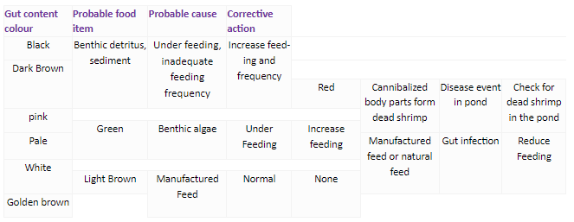
7、Store the feed in a clean， cool and ventilated place， out of the sun. Stack bags neatly on trays (no more than 10 bags per stack)， 30 cm from walls and prevent them from coming into direct contact with wet floors. Avoid over-handling feed bags and always handle them with care. Pellet feed is durable， but not indestructible. Excessive or rough handling can increase the incidence of fines， which can increase feed losses. Keep different types of feed separate and clearly marked.When rotating stock， use older feeds first (those that have been stored and for the longest period of time). Follow the "first in， first out" principle. Feed should preferably be used within the first 2-4 weeks after production and should not be stored for more than 2-3 months. Keep the warehouse and outside premises clean and use mouse traps to keep mice away.
Do not store any fuel or liquid items in the feed store. It is important to protect feed sacks from sunlight and rain by storing them in a simple pond-side storage shed away from the ground. Proper care should be taken to protect feed bags from moisture during rainy weather. Store empty feed bags properly and recycle them by selling them to traders.

