Application of medical oxygen generator
1、 Working principle of medical oxygen generator image png

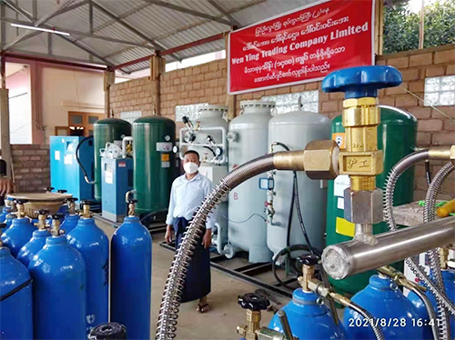
Medical oxygen generator is a new type of equipment based on pressure swing adsorption (PSA) technology and using molecular sieve physical adsorption and desorption technology to extract oxygen from the air. It takes air as raw material and molecular sieve as adsorbent. Under normal temperature and low pressure， it uses the characteristics that the capacity of molecular sieve for nitrogen increases when pressurized and decreases when depressurized to form a cyclic process of pressurized adsorption and depressurized desorption. At the same time， carbon dioxide， carbon monoxide， gaseous acid， alkali and other gaseous oxides in the air are adsorbed or filtered， so that the purity of the produced oxygen can reach 93% ± 3 (V / V)， and ensure that the produced oxygen does not contain components harmful to human body， so as to make the oxygen meet the requirements of medical oxygen. The whole oxygen production process is a low-pressure physical adsorption process without chemical reaction， which is safe and reliable. The raw material is air and has no pollution to the environment. Compared with the traditional oxygen use in hospitals (liquid oxygen and steel cylinder oxygen)， PSA medical oxygen generator is safer， more convenient， more economical and more environmentally friendly.
2、 Industry application
The decentralized oxygen bottle or liquid oxygen supply mode has some disadvantages， such as frequent replacement of oxygen bottles， insufficient industry competition， transportation needs special vehicles， use danger and so on. Most of the large PSA molecular sieve oxygen production equipment are vertical， with large volume， large floor area and high noise. It is not suitable for the promotion of small and medium-sized hospitals， and staff must be on duty to record data regularly， which can not realize remote control. The ATF molecular sieve medical oxygen generator used in small and medium-sized hospitals has some disadvantages， such as high moisture content in the produced oxygen， humanized control and display system， high noise and so on. However， there are strict restrictions on the volume， noise， operation cost and price of equipment in medical and household environment. It is necessary to study more advanced equipment to make it work more efficient， compact structure， lower noise and lower cost.
Therefore， with the progress of science and technology， small and medium-sized hospitals hope to have a high-performance ATF medical molecular sieve adsorption oxygen generator with small volume， simple operation， stable operation， low noise， convenient maintenance and remote monitoring to replace their existing centralized oxygen supply equipment. The application of high-tech integrated medical molecular sieve oxygen production equipment will change the traditional mode that small and medium-sized hospitals provide oxygen by oxygen plants. Hospitals can produce oxygen for clinical use.
At the same time， with the rapid development of network technology and intelligent control technology， the use of networked distributed monitoring and remote control technology has been widely used in more and more fields. The realization of networked distributed remote control of oxygen production equipment and oxygen consumption management represents the development direction of technology in this field at home and abroad.

