Liquefied Natural Gas (LNG) Safety Issues - How to Blow Out LNG Tanks

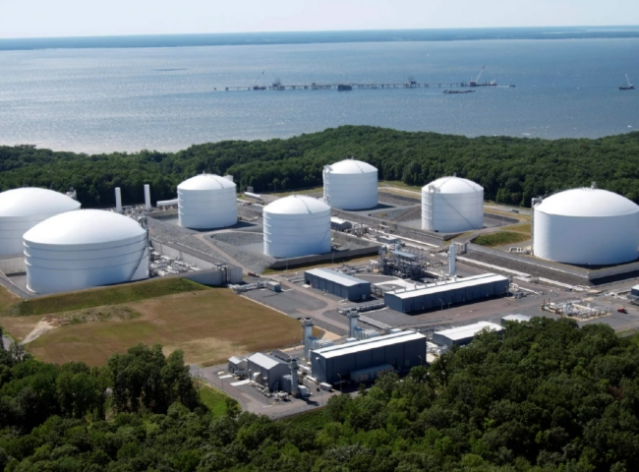
Liquefied natural gas (LNG) is one of the most useful forms of natural gas available today， used in both domestic and industrial production. Natural gas that has been cryogenically frozen and liquefied usually consists of methane and a smaller percentage of other hydrocarbons.
The advantage of this gaseous mixture is that it can save valuable storage space due to its reduced volume compared to non-compressed natural gas. Although this fuel is relatively safe to store， transport and handle， there are still misconceptions about the dangers of this liquid.
In this article， we will cover the various properties of LNG and discuss how to safely store this important fuel source.
What is LNG?
Liquefied Natural Gas (LNG) is natural gas at sub-zero temperatures， where it condenses to a liquid state. LNG fractions are produced by subcooling the natural gas to very low temperatures， where the newly formed liquid is only 1/600th of its volume in the gaseous state.
LNG is a very stable compound that can be stored indefinitely at ambient temperatures， but when spilled onto any external surface， it evaporates quickly and completely without leaving any trace. In addition， LNG is non-toxic and when these properties are combined， fire and other safety hazards are impossible in the event of an accidental spill.
At what temperature does natural gas liquefy
In order for natural gas liquefaction to occur， the gas must be cooled to -260° F. At this temperature， the gas turns into a liquid while shrinking to a volume 600 times smaller than its gaseous state.
How is LNG transported?
LNG is usually stored and transported in specially designed storage tanks. For marine transportation， manufacturers use large LNG container ships to transport the product to distant locations.
These marine vessels have a multi-wall design that separates the tanks and their contents from the hull of the vessel. They are separated by about 8 feet， minimizing the possibility of an onboard disaster during transport. Similar tank structures are used for onshore transport and are built to exacting specifications with double-walled compartments with built-in pressure relief systems.
LNG risks and safety issues
The LNG manufacturing industry has been safely transporting large volumes of this fuel for decades. However， as with all industrial processes involving the use of potentially combustible materials， there have been a number of high-profile accidents in the past.
For example， in Cleveland， Ohio， during World War II， a poorly constructed sealed tank failed and leaked into the sewer of a nearby residential area. The released vapors were subsequently ignited， killing more than 100 people and injuring about 200. Although incidents like the one described above have become rare due to the strict enforcement of storage and transportation standards， the potential LNG hazard still exists.

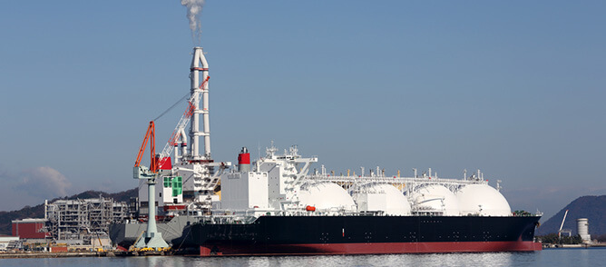
Potential Hazards Associated with LNG Spills
The most common LNG spill risks include
Vapor ignition in the presence of an appropriate source
Boiling liquid expansion vapor explosion (BLEVE)， due to rapid vaporization
Following LNG vessel failure
Rapid phase change， where large amounts of spilled LNG explode without burning
Fires caused by rupture of storage tanks during transportation
Low temperature burns in direct contact with skin
Methane asphyxiation
Is LNG flammable?
The main component of LNG is methane， a relatively stable compound that is not easily combustible. In its liquefied state， natural gas is non-flammable， but if it leaks， it can form vapor clouds that can ignite under the right conditions.
Spillage of liquefied natural gas in water
LNG does not react when it encounters water. If LNG is accidentally spilled into a body of water， it will evaporate quickly and leave no trace. Therefore， there is no need to worry about causing harm to aquatic life， whether it is plants or animals.
LNG spills on the ground
When LNG is spilled on the ground， it behaves similarly to water. As long as no ignition source comes into contact with its flammable vapors， the fuel will quickly form vapor and dissipate completely and harmlessly.
Cleaning LNG Tanks to Improve Safety
Although LNG is considered to be quite safe， care must be taken when handling it to ensure a higher safety outcome. Empty LNG tanks or partially filled LNG tanks can be cleaned by passing an inert gas through their interior to eliminate substances that increase the chance of combustion.
Nitrogen is ideal for LNG tank purging because of its inert， non-flammable properties. Once properly purified， LNG can be safely transported in the vessel with minimal risk of accidental combustion.
For more effective nitrogen purging of LNG storage tanks， the use of dedicated on-site nitrogen generators (PSA nitrogen generators， nitrogen equipment) is highly recommended.

