Nitrogen generator for food packaging， 30 cfm， 99.9% purity， 6 KG/CM2 working pressure

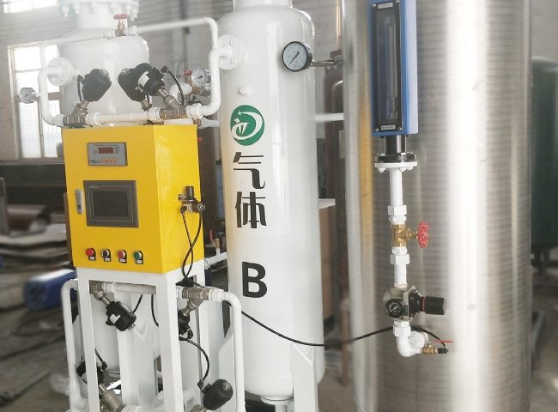
Suzhou XITE has installed a 30 cfm nitrogen generator for food packaging with 99.9% purity and 6 KG/CM2 operating pressure.
According to research， oxygen and moisture are the main culprits in food spoilage， with its components combining or "oxidizing" with oxygen. The most effective way to prevent food from being damaged by oxygen is to remove it and replace it with an inert gas， a common inert gas being nitrogen， a gas whose application in casual food packaging is now well known. The shelf life of snack foods such as chips， extruded snacks， breakfast cereals， nuts and other dried fruits is improved by expelling the air around the food in the package.
The range of food packaging products sold by Suzhou XITE are

