How does cryogenic nitrogen equipment work?

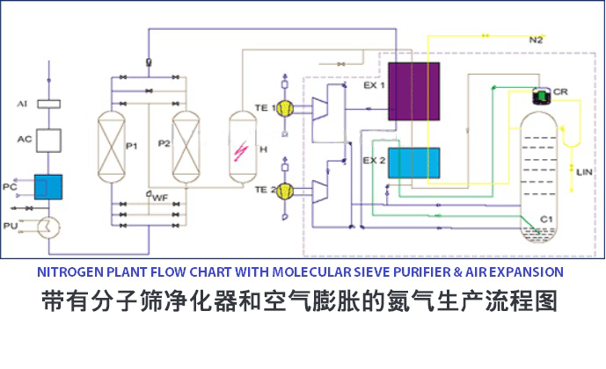
The work of cryogenic nitrogen generators - first of all you should understand the production process of nitrogen generators with cryogenic technology before buying equipment machinery. Compared to non-cryogenic processes (PSA， VPSA)， cryogenic distillation technology is more efficient and produces nitrogen with higher purity. It is used on a large scale to preserve food， biological specimens (semen， blood)， remove skin warts， etc. With cryogenic equipment， you can increase the productivity of your business and be cost effective. The gas equipment has a pressure range of 2-5 bar and produces nitrogen with a purity of 99.99%. With the installation of our machines， you will recover the cost of the cryogenic equipment within two years.
The cryogenic nitrogen plant is an industrial system that produces nitrogen by liquefying the atmosphere in an air separation unit (ASU). Nitrogen is one of the most important industrial gases， accounting for approximately 78% of the earth's atmosphere by mass. In fact， it is known as a specialized industrial gas due to most of its industrial applications. This gas is known for its inertness， which is why it is used in manufacturing operations. It is used in manufacturing electronics， brewing beer and food packaging. There are many other important applications for inert gases. Industries meet their nitrogen needs by ordering nitrogen cylinders or installing liquid nitrogen plants on site.
How does a liquid nitrogen plant work?
More and more industries and businesses are now choosing to install cryogenic nitrogen plants because it is efficient， economical and provides a ready supply of inert gas. Ordering nitrogen cylinders is fraught with a lot of uncertainty due to supply chain issues. In addition， the use of inert gas via cylinders is expensive. Installing your liquid nitrogen equipment will reduce costs while ensuring a constant supply of inert gas. Our equipment machinery offers an impressive return on investment (ROI). The equipment is expected to break even within two years， which is very impressive. Producing your own nitrogen has many other benefits， such as you will be able to use all the nitrogen you produce， unlike cylinders where about 10% of the nitrogen is not used.
Nitrogen is produced in a cryogenic nitrogen generator by extracting air from the atmosphere. As the atmospheric air is drawn into the air separation unit (ASU)， it is compressed in the compressor. It is then transferred to a purification system where impurities such as hydrocarbons， moisture and carbon dioxide are avoided. Here， the air is directed to a heat exchanger where it is liquefied at low temperatures. At this stage， the air is placed in a high-pressure distillation column where the nitrogen is physically separated from oxygen and other gases. The nitrogen thus formed is collected and placed in a low-pressure distillation column where it is distilled until it meets commercial specifications.

