Liquid oxygen in-pump compression process with nitrogen circulation booster (I)

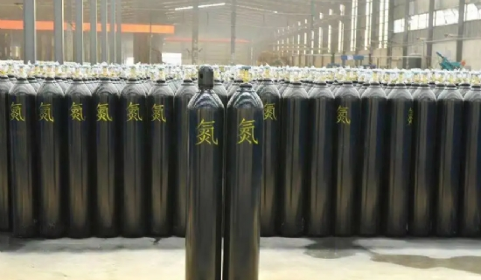
1 Advantages and disadvantages of the internal compression process of nitrogen circulation intensifiers
The first air separation equipment for the internal compression process of liquid oxygen pumps was developed by Linde in Germany in the 1970s. However， this 35100m3/h air separation equipment for a fertilizer plant in Navmada， China， instead of using the high pressure air generated by the current common air booster as a heat source to vaporize high pressure liquid oxygen in the main heat exchanger， a nitrogen circulation booster is used to reheat the gas nitrogen at the top of the pressure tower through the heat exchanger. It is then compressed by the nitrogen circulation booster into high pressure nitrogen， which enters the high pressure heat exchanger The high pressure nitrogen enters the high pressure heat exchanger to vaporize the liquid oxygen， liquefies itself and is then recirculated into the pressure tower. Three years later， in 1979， Linde supplied three sets of 28，000 m3/h air separation plants to the Zhejiang Zhenhai Refinery， Ningxia Chemical Plant and Urumqi Fertilizer Plant in China， and again introduced the liquid oxygen pump compression process using a nitrogen circulation booster.
Instead of using the internal compression process of the air booster， which was commonly used at that time， the internal compression process of the nitrogen circulation booster was used for two main reasons.
(1) the use of three sets of 28000m3 / h air separation equipment or switching heat exchanger refrigeration method to remove moisture and carbon dioxide in the air process. The air is not dried and contains a very small amount of carbon dioxide before entering the cold box， such as the use of unpurified air as booster air， then this air in the heat exchange with the return of the low temperature medium， the moisture and carbon dioxide in the air is bound to freeze on the high pressure air channel. This problem can be avoided by compressing the low pressure nitrogen in the cold box to the required pressure and feeding it to the main heat exchanger.
(2) As the required production capacity of the three sets of air separation equipment is: 28000m3/h of oxygen at a pressure of 9.6MPa and 37000m3/h of nitrogen at a pressure of 8.OMPa. According to this calculation， the pressure of nitrogen out of the circulating booster can reach 12MPa. Thus， the use of nitrogen circulating booster not only solves the problem of vaporization of high pressure liquid oxygen heat source， but also meets the user's high pressure nitrogen Requirements， than the use of air booster can save a large flow of high-pressure nitrogen press， greatly saving the investment in equipment.
However， if there can be a stream of purified air from the raw material air compressor as a heat source to vaporize high pressure liquid oxygen， then the use of nitrogen circulation booster internal compression process has a great disadvantage， that is， compared with the air booster internal compression process， it has higher energy consumption， mainly for the following reasons:-
(1) Nitrogen is used for heat transfer and condensation， and its performance is worse than that of air. For example， the condensation temperature of air is higher than that of nitrogen， and if the same condensation temperature is to be achieved， it is necessary to make the pressurization pressure of nitrogen higher than that of air; the heat of condensation of air is also higher than that of nitrogen， and the amount of nitrogen required to vaporize the same high pressure liquid oxygen is greater than that of air.
(2) The non-repetitive heat loss of the air pressurization process gas in the main heat exchanger is less than the non-repetitive heat loss of the nitrogen cycle pressurization process. Because the use of air booster process， this part of the air into the main heat exchanger only 1 time， and thus its non-repetitive heat loss is only 1 time; and nitrogen cycle pressurization process， nitrogen as part of the raw material air into the main heat exchanger， forming the first non-repetitive heat loss， out of the main heat exchanger nitrogen pressurization and then into the main heat exchanger， resulting in the second non-repetitive heat loss.
(3) As the nitrogen cycle pressurization process requires a large amount of nitrogen from the distillation tower as a gas source for evaporating oxygen， its gas volume is much larger compared with the air cycle. The amount of nitrogen extracted directly from the top of the tower is too large， which will affect the reflux ratio in the distillation tower and destroy the original good distillation efficiency， resulting in a rapid decline in the extraction rate of the product oxygen and argon， the air compressor flow increases， and the energy consumption of the whole equipment increases. As the nitrogen cycle boosting process has the disadvantage of high energy consumption， after the emergence of room temperature adsorption purification air process， the internal compression process with air boosting instead of the internal compression process of nitrogen cycle boosting.

