What are the uses of nitrogen in the oil and gas industry?

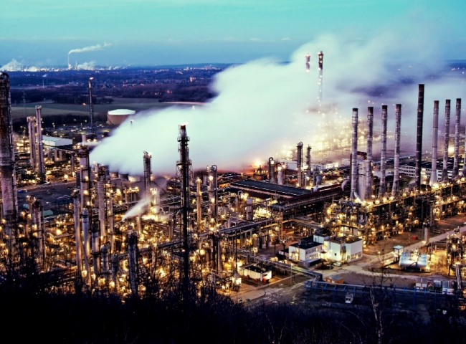
Nitrogen is a gas that is found in large quantities in the air. It has many applications such as food processing， heat treatment， metal cutting， glass manufacturing， chemical industry and many other processes that rely on nitrogen in some form or capacity.
As an inert gas， nitrogen provides most of the capacity for oil， gas and petrochemical companies. Used primarily for plant maintenance， start-up and shutdown preparation， nitrogen purging and subsequent nitrogen leak testing constitute the critical path to favorable results for any project. As a result， nitrogen has become extremely important for both onshore and offshore applications.
When we talk about safety in the oil and gas industry， nitrogen is paramount. This gas ensures safety in cleaning and other situations where an inert atmosphere is required. With the origin of low cost and reliable nitrogen production， many oil and gas industries have opted for nitrogen generators. It has a number of other applications as well， read below for other applications of nitrogen in the oil and gas industry.
Nitrogen Filling
Nitrogen blanketing， also known as tank filling and tank lining， is a process in which nitrogen is applied to storage vessels consisting of chemicals and hydrocarbons that are volatile and react with oxygen. When a tank is purged with nitrogen， the material inside the tank (usually a liquid) does not come into contact with oxygen. The purge gives the product a longer life and the potential explosion hazard is reduced.
Nitrogen purging
To replace any undesirable or hazardous atmosphere with an inert， dry atmosphere， purging with nitrogen is used， i.e.， limiting the oxygen content so that it does not react with other explosive mixtures and hydrocarbons. Displacement and dilution are the two most common purging methods. Which method is suitable for which system depends on its geometry. The displacement method is more effective for simple systems， and the dilution method is used for complex systems.
Cooling the refinery catalyst
When a refinery is to be shut down， it is desirable to minimize the catalyst temperature associated with the process as early as possible. To do this， large amounts of nitrogen can be injected into the catalyst using pumping equipment to cool the catalyst quickly and save downtime.
Hitt is a turnkey supplier of air and gas solutions and manufactures quality on-site nitrogen generators.

