**What type of oil should I put in my air compressor?**

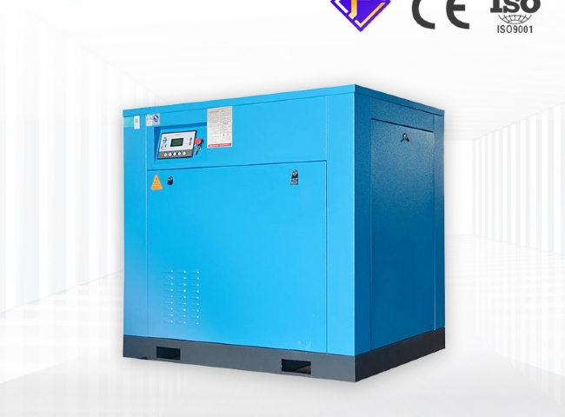

You probably don't go months at a time without changing your car's oil or rotating your tires. You know that putting off car maintenance can have terrible consequences， even to the point of putting you out of commission altogether. Compressor equipment works the same way. Therefore， failing to schedule regular compressor maintenance can put your store in a bind.

Regular maintenance doesn't have to be a big deal. In fact， many vehicle repair stores perform basic maintenance in-house. If this is the route you want to take， here are some tips to consider.

Check those lubrication levels. This means every 24 hours. Low lubrication levels will prevent the compressor from running at optimal performance. When lubrication levels become low， replace them with a high-quality， specially designed lubricant for rotary screw compressors， such as Ingersoll-Rand? Super Coolant. For reciprocating models， Ingersoll-Rand's Synthetic All-Season Select is a good choice. Depending on your compressor， these lubricants will make a big difference in the efficiency and wear of your equipment components.

Change your filters in a timely manner. The filter's job is to keep your compressor air clean. If your filter is dirty， it won't be able to do this effectively. Monitor your filter regularly and replace it if it looks dirty to keep the air clean.

Make sure the correct belt tension is applied. Your compressor's drive belt transfers energy from the compressor motor to your tools. If the belt is not at the proper tension， this energy transfer may be compromised， making your tool run less efficiently.

These are just a few basic maintenance tips that can keep your operation running smoothly for longer.