Why can’t oxygen cylinders be contaminated with oil?

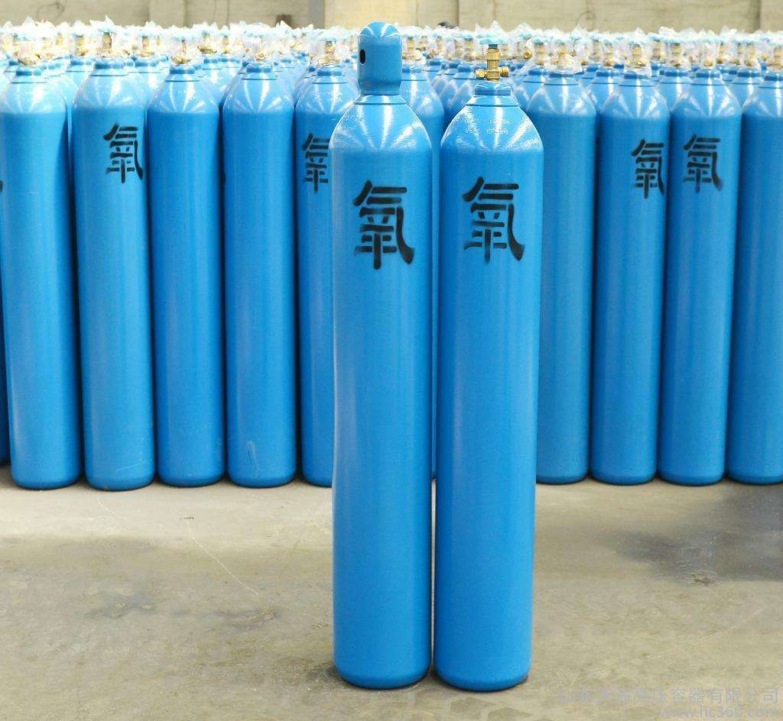
This issue is not entirely well known to managers involved in operations， storage and transport. Oils， those containing unsaturated fatty acids， tend to vaporise exothermically. Oil gauze . Spontaneous combustion of tarpaulins is caused by oxidation in air when the auto-ignition point is reached. Oil in the air is slow to vaporise， and the heat generated is emitted quickly， so it is generally not easy to spontaneous combustion. Since pure oxygen has strong oxidising properties， it can promote the violent combustion of combustible materials. When oil encounters pure oxygen， the gasification speed is greatly accelerated and a large amount of heat is released. The temperature rises rapidly and will soon cause combustion. If the mouth of the oxygen cylinder is stained with oil， when the oxygen is rapidly ejected， the oil rapidly undergoes oxidation reaction， and the heat generated by the friction between the high-pressure airflow and the mouth of the cylinder further accelerates the oxidation reaction， and the oil on the oxygen cylinder or pressure-reducing valve will cause combustion or even explosion， which is why the oxygen cylinder， especially the mouth of the cylinder and the accessories that are in contact with the oxygen， are forbidden to come into contact with the oil.
Therefore， in the storage， in the process of transport and use， what measures should be taken to prevent the oxygen cylinder and other oil pollution?
1. Oxygen cylinders and warehouses storing oxygen should have strictly prohibited oil signs to remind people that: in addition to oxygen cylinders are not allowed to come into contact with oil， but also accessories that come into contact with oxygen (e.g.， pressure-reducing valves) welding torches . Gas delivery hoses， etc.) ， cannot come into contact with oil and grease.
2. Warehouses and transport vehicles storing oxygen cylinders are strictly prohibited from storing and transporting oil and grease together. The same transport. Such as warehouse. If the vehicle is contaminated with grease， it should be completely removed before storage or shipment.
3. Oxygen cylinders are being stored. During transport， wear a helmet to prevent the intrusion of grease or dust or mechanical damage to the mouth of the oxygen cylinder.
4. For use. Storage and transport operations and management personnel shall not wear contaminated oil-contaminated overalls. Gloves and other contact with the oxygen cylinder and its accessories. 5. If the cylinder is contaminated with oil， it should be promptly wiped with carbon tetrachloride or cleaner， but not with flammable organic solvents.

