What are the common methods and principles of gas separation in industry?

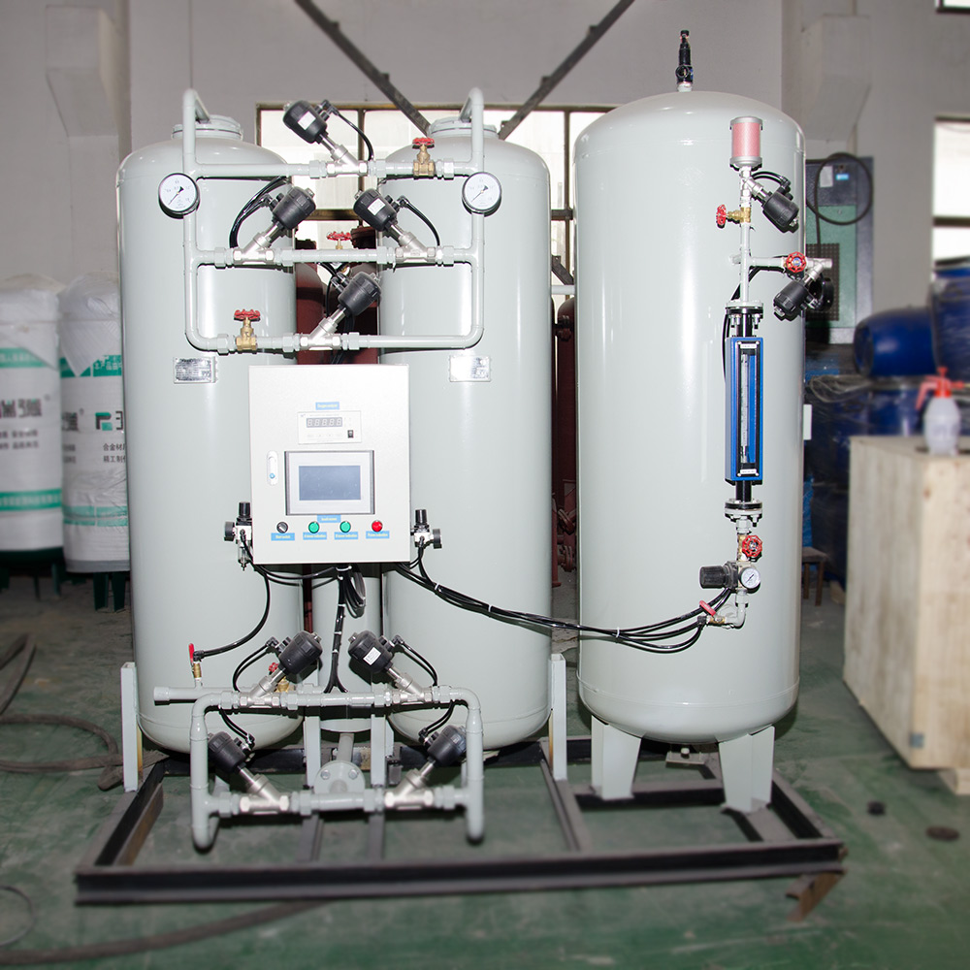
Commonly used industrial gases include oxygen， nitrogen， argon， carbon dioxide， liquid ammonia， liquid chlorine， acetylene gas， hydrogen and so on. Industrial gases production methods are more， now choose to introduce some common production methods.
I. Oxygen
Industrial oxygen production methods mainly include air liquefaction separation and distillation method (referred to as air separation method)， water electrolysis and pressure change adsorption method. Air separation method for the production of oxygen process is: absorption of air → carbon dioxide absorption tower → compressor → cooler → dryer → freezer → liquefaction separator → oil separator → gas storage tank → oxygen compressor → gas charging. The basic principle is to liquefy the air， using the different boiling points of the components in the air in the liquefaction separator for separation and distillation， the production of oxygen. The research and development of large-scale oxygen generation unit put into use， making oxygen energy consumption is constantly reduced， and easy to simultaneously produce a variety of air separation products (such as nitrogen， argon and other inert gases， etc.). In order to facilitate storage and transportation， the liquid oxygen separated by the liquefaction separator is pumped into the cryogenic liquid storage tank， and then transported by tanker trucks to the deep-cooled liquefaction of permanent gas charging stations. Liquid nitrogen and liquid argon are also stored and transported by this method.
Nitrogen
The main production methods of industrial nitrogen are air separation method， variable pressure adsorption method， membrane separation method and combustion method.
The nitrogen obtained by air separation method has high purity and low energy consumption. Variable pressure adsorption nitrogen technology is the use of 5A carbon molecular sieve selective adsorption of components in the air， oxygen， nitrogen separation of nitrogen production， nitrogen products， high pressure， low energy consumption， product purity can meet the national standards: industrial nitrogen ≥ 98.5%， pure nitrogen ≥ 99.95%.
Argon
Argon is the most abundant noble gas in the atmosphere， and its production method is mainly air separation method. In the oxygen production process， the boiling point of -185.9 ℃ or so from the liquefaction of the fraction separated from the liquefaction separator is liquid argon.
Fourth， carbon dioxide
Carbon dioxide production methods are: the production of carbon dioxide lime by-products， brewing fermentation process by-products of carbon dioxide， heavy oil， coke and other combustion carbon dioxide， ammonia industry by-products of carbon dioxide and so on. At present， most of the raw materials of ammonia industry are gas， refinery gas， coke oven gas and coal， whose main components are hydrocarbons and elemental carbon with different hydrogen-carbon ratios， and generate syngas with hydrogen and carbon monoxide as the main body under high temperature with the action of water vapor and carbon monoxide is transformed into carbon dioxide. Carbon dioxide purification methods are: absorption， pressure change adsorption method， adsorption distillation method and membrane separation method.
V. Ammonia
Ammonia is mainly produced by direct synthesis method. Ammonia synthesis process is: in the water gas generator to the red-hot coke blown into the air and water vapor， the first to get nitrogen， hydrogen gas mixture， and then with the scrubbing heat exchange， condensation of carbon dioxide and absorption of carbon dioxide and other production processes to prepare the raw gas. The refined gas mixture is sent through filters， coolers， ammonia separators and heaters to the synthesis reactor where liquid ammonia is separated in a separator.
VI. Chlorine
The main method of producing chlorine gas for industrial use is the electrolysis of saturated saline water. Higher purity chlorine gas is obtained by electrolysis of molten chlorides for the preparation of active metals. The use of air or oxygen can catalyze the organic synthesis industry by-products of hydrogen chloride， so that the oxidation and conversion to chlorine.
Seven， acetylene gas
Acetylene production methods are mainly calcium carbide hydrolysis， methane or hydrocarbon high-temperature combustion cracking method and plasma cracking method. Calcium carbide hydrolysis process is short， high product purity， but energy consumption. Most dissolved acetylene production adopts this method. According to the dissolution characteristics of acetylene， acetylene gas is compressed and charged into a solvent and stored in cylinders filled with porous packing. Acetone， as an excellent solvent， is adsorbed by the packing inside the cylinder for dissolving and releasing acetylene， which serves to increase the effective volume of the cylinder and reduce the explosive properties of acetylene gas. The role of the overall calcium silicate porous filler is to uniformly adsorb acetone and prevent the spread of acetylene decomposition explosion. Promote the use of dissolved acetylene cylinders， not only to facilitate the use and improve efficiency， but also to improve the environment， saving calcium carbide consumption， but should ensure that the porous filler cylinders are not damaged or contaminated， acetone solvent filling should meet the acetylene gas charging needs， so as to ensure safety and reliability. Dissolved acetylene production charging process is: crude acetylene gas after the occurrence of chemical purification， removal of sulfur， phosphorus and other impurities， and then by compression and drying， filling into the dissolved acetylene gas cylinder.
Eight， hydrogen
Industrial hydrogen production methods are: mineral combustion into hydrogen， water electrolysis hydrogen， hydrogen through the semi-water gas method. Water electrolysis method of hydrogen technology is reliable， simple operation， easy maintenance， does not produce pollution， high purity of hydrogen， only its power consumption， high cost， the production development is subject to certain constraints， mainly for the supply of hydrogen purity requirements and the amount of hydrogen is not too large for the use of users. However， with the application of new technologies to promote the improvement of water electrolysis technology， so that the cost of water electrolysis hydrogen technology continues to reduce， power consumption continues to decline， is expected to become a "clean energy" of the most important production methods. Currently， hydrogen production methods being researched and developed include: electrochemical decomposition of water to produce hydrogen， and photocatalytic production of hydrogen.

