**Automatic control of air turbine compressors for large air separation plants**

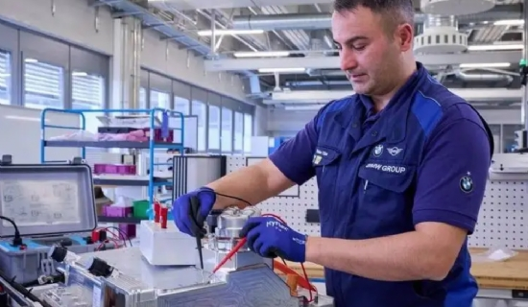

In recent years， the scale of air separation equipment has become larger and larger， and the internal compression process has become the mainstream process. Its supporting air compressor (including booster compressor for internal compression) specifications have also increased， the original domestic products have been difficult to meet the needs， so most of the large air separation equipment turbocompressors (including booster) imported from abroad. Our company has carried out a number of different manufacturers of large compressor control design and commissioning， the control situation and insights are introduced as follows.

1、 Control principle

The basic control requirements of the turbocompressor is to ensure the safe and smooth operation of the premise to make full use of the compressor allowed to work area， so that the unit work in the process requirements of the pressure and dosage change range (such as variable load adjustment and air separation equipment purging pressure and dosage adjustment)， stable and reliable working conditions， easy to operate， a high degree of automation. The working state of the compressor is as transparent as possible to the operator， easy to analyze and operate， and has a long history of trends to check.

2、 Control implementation method

According to the different requirements of the project， the compressor can have different control implementation methods， generally the following two.

(1) The compressor unit is controlled by the unit's own control system (generally PLC)， and the main parameters of the unit are transmitted to the DCS using the communication method， which is only displayed on the DCS operation station to achieve the purpose of monitoring.