**How does the oxygen generator work?**

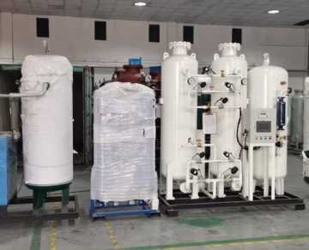

Many industries require high purity oxygen to meet their production needs. Without a dedicated oxygen generator， the cost of obtaining oxygen can be high and impractical. Understanding how oxygen generators work can help you decide if this type of generator is right for you.

What is an oxygen generator?

An oxygen generator is an application that uses a unique selective adsorption technology to separate oxygen from the nitrogen and other components of compressed air. Oxygen can flow through a sieve that retains any nitrogen， producing high purity oxygen.

Oxygen generators are very similar to nitrogen generators. One difference in the oxygen generator is that the material inside the sieve is made of zeolite rather than carbon.

The air flowing through the oxygen generator is separated into the various gases that make up air. The sieve selectively absorbs nitrogen along with the zeolite， thus allowing high purity oxygen to flow through the generator and be used in applications or stored in tanks as needed.

What are the uses of oxygen generators?

Oxygen generators can be used in a variety of applications including medical， sewage and wastewater treatment， paper， food and beverage industries， glass manufacturing， mining， commercial fish farming， metallurgy， gasification processes， and more.

How do oxygen generation systems work?

So， how does an oxygen generator work? The generator uses an adsorption tower with zeolites to retain nitrogen while allowing oxygen to enter the collection tank. The generator continues to operate until the zeolite sieve reaches full saturation and can absorb no more nitrogen.

Once the zeolite has completely absorbed as much nitrogen as it can handle， the cylinder is depressurized， releasing the nitrogen to the atmosphere. This process is regulated by a device that detects the saturation of oxygen and nitrogen.

Oxygen Generator and Oxygen Concentrator

The terms oxygen generator and oxygen concentrator are often used interchangeably and， in general， the terms mean the same thing. Often， the term oxygen concentrator is used to describe smaller， more portable oxygen generators， while the term oxygen generator is used to describe larger units that produce large quantities of oxygen for industrial use.

*** Translated with www.DeepL.com/Translator (free version) ***