**Maximum oxygen output through XITE oxygen generators**

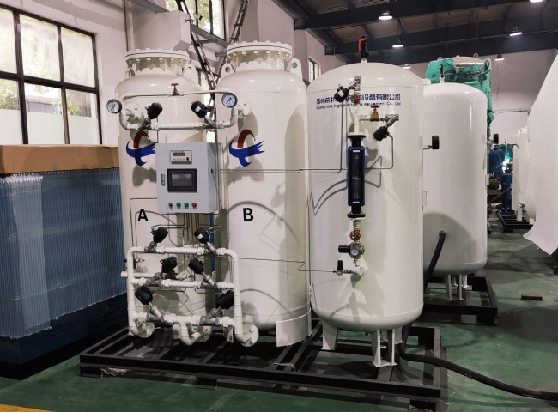

In many industries， production without the use of oxygen is not cost effective because it does not allow you to increase your productivity. Oxygen is the core gas that is used for smoother and more effective applications in all areas of life and industry.

If you are in an industry that performs chemical operations involving the formation of sulfuric acid， nitric acid， etc.， or medical operations， then you should not lose any opportunity to purchase beneficial oxygen equipment.

Suzhou Hite China is the leading manufacturer of nitrogen equipment and oxygen equipment. Atmosphere provides both oxygen and nitrogen. However， Suzhou Hi-Tech is very smart in separating these two gases by using Pressure Swing Adsorption (PSA) system.

It is considered to be the best and pure nitrogen generator as well as oxygen generator. It produces oxygen equipment with unique and worthy attributes such as.

* Produces pure oxygen with a 92-95% nutrient content.
* Continuously engage the bypass arrangement， using a precise rotation schedule.
* Uses an air dryer that constantly balances the expiration point and increases it to the desired level by not using pressure or purge drops， etc.
* Fully mechanized， thus saving valuable time and manual operations and costs.
* Provides good automation such as 1w+1s.
* You can easily and freely install these devices and operate them with full convenience.
* Provide good maintenance assistance.
* High filtration level is obtained effectively.
* After achieving high filtration level， you can control the oil content within 0.003ppm.
* It has no time limit and you are free to generate oxygen when you want.
* The best facility is that you can get free service for up to 2 years.

If you want reliable functionality， fast and meaningful results， then please call or send us your queries on our website.

We will contact you immediately and guide you to the most accurate oxygen equipment of unparalleled quality and standard.