Cost and price of automatic liquid nitrogen equipment

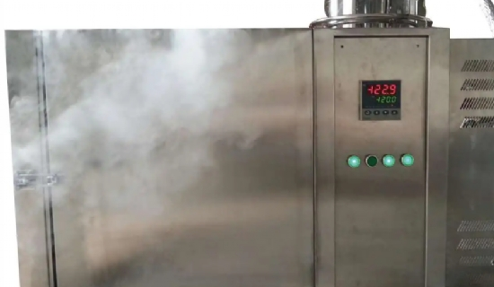
Nitrogen generators are used to produce nitrogen for various industrial and medical purposes. This gaseous element makes up about 78% of the Earth's atmosphere by volume and is also present in the Earth's interior. However， nitrogen for commercial purposes is generated by nitrogen generators because the atmosphere is only 87% air， while industrial and medical applications require nitrogen gas with a purity of up to 99.99%. Most industries now prefer to install plants on site to generate their own gas. The earlier method of meeting your needs by ordering supplies from industrial gas retailers is now obsolete as it is subject to uncertain supply.
How liquid nitrogen is made and applied
Nitrogen generators use atmospheric air， which is compressed in an air separation plant and then fed into a molecular sieve where impurities such as carbon dioxide， hydrocarbons and moisture are removed. The air is then moved into an exchanger， where it is cooled to a cryogenic liquid. Afterwards， it is moved into a high-pressure distillation column， where the nitrogen is separated from the other gases and distilled until the desired purity specifications are achieved. The nitrogen is deposited at the top of the distillation column.
Applications of Nitrogen
Nitrogen is an important industrial gas in the world and the cost of nitrogen generator installation. In fact， it is a specialized industrial gas used in the manufacture of fertilizers， nitric acid， nylon， dyes and explosives. It is reported that more than 150 million tons of ammonia are produced annually. In addition， the gas is used to provide inert gas for preserving food and for manufacturing diodes and transistors. This non-reactive gas is used to anneal stainless steel products.
The various applications of nitrogen include.
Applications in wind tunnels， heat treatment furnaces and autoclaves to help create incredibly strong and lightweight materials.
Nitrogen is used along with other welding gases to weld automotive parts， frames， mufflers and other components
It is very effective at pushing liquids through pipes and is used to shield oxygen-sensitive materials from the air.
It is an excellent choice for preventing oxidation and is an important part of the heat treatment process
Gaseous nitrogen is used for purging， pressure transfer， mixing and covering. It provides protection against moisture intrusion， oxidation， degradation and contamination
For freezing and transport of food products
Cryopreservation of biological samples， such as sperm， eggs and animal genetic samples
Coolant for superconductors， vacuum pumps and other materials and equipment
Cryotherapy to avoid skin abnormalities
Protection of materials from oxygen exposure
Quickly freeze water or tubing to work on it without valves
As a source of extremely dry nitrogen
For branding cattle.

