**Why are oxygen and nitrogen generators the best choice to ensure efficient production in industrial production?**

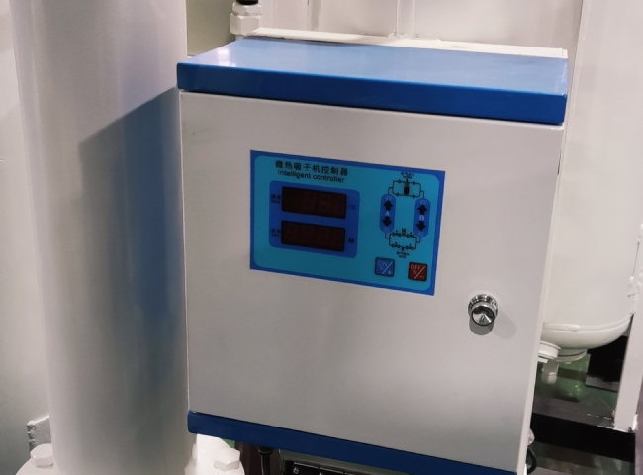

Today， the utilization of nitrogen equipment manufacturers and oxygen generators has expanded to a lot in the industrial sector. You may not know that the use of oxygen or nitrogen is not only in the medical industry， but also for industrial purposes.

As you know， oxygen has a great role in saving the lives of human beings. Before buying an oxygen generator， we recommend you to determine your requirements. With the advancement of technology， people have been able to develop and design a set up that can provide both oxygen and high purity nitrogen.

As a result， the nitrogen equipment supplier industry， like China Hite， has also begun to develop markets outside of China as the business is growing massively.

If you are finally ready to buy a device， you should immediately conduct an online search to find out the outstanding features of the product. For instance， minimum cost， no maintenance， latest features and hassle-free operation are some of the factors you need to look out for.

Oxygen is often needed in facilities， mining sites， chemical facilities， medical institutions and other places. To meet the requirements of people， the best oxygen generator suppliers design and develop equipment that can help purify the products of the plant.

A simple search through the internet will be helpful to you as you will find many manufacturers and suppliers who are selling these products at competitive prices. When buying equipment， you need to look not only at the price， but also at the technology used. In addition， you need to check for features such as reliability， stability， longevity and ease of use. And at the end， you also need to look for the prices of the various manufacturers. On the other hand， exploring customer reviews and testimonials will also help you a lot in order to understand the technical features of the product.