**Application of oxygen generator in chemical industry and new material industry**

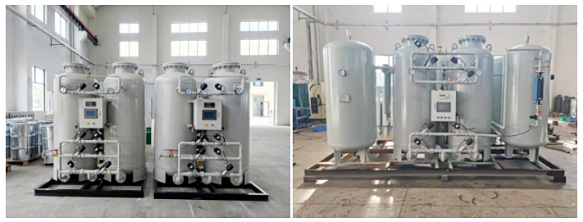

Oxygen making equipment is mainly used for chemical raw gas， pipeline purging， atmosphere replacement， protective atmosphere， product transportation， etc. It is mainly used in chemical industry， spandex， rubber， plastic， tire， polyurethane， biotechnology， intermediate and other industries. Many chemical industries have low requirements for nitrogen purity， and many can be used if the purity is greater than 98%. Acrylic acid oxidation explosion-proof， float glass process flow， protect the chemical industry， create an oxygen free atmosphere in the chemical process， improve the safety of the production process， fluid transmission， power source and other protective gas in replacement， cleaning， sealing， leak detection and dry coke quenching; Gas and petroleum industries such as catalyst regeneration， petroleum fractionation and chemical fiber production， improve petroleum processing and refining processes， oil storage and pressurization of oil and gas field wells， pipeline cleaning and purging， solvent recovery， etc. Nitrogen filling and purification of storage， container， catalytic cracking tower， pipeline， etc; Pneumatic leakage test of pipeline system， etc

Combustibles can burn in a substance， that is， this substance has combustion supporting property.

Generally， oxygen is combustion supporting.

The combustion supporting property of oxygen is actually a manifestation of oxidation， because combustion is actually a luminous and exothermic redox reaction. Because oxygen is oxidizing， when oxygen encounters combustibles (generally reducing)， if the temperature reaches the value required for the reaction， it will react， that is， combustion. At present， oxygen combustion supporting is used in all aspects of industry.

**Customer site case:**

