**The difference between single-stage and two-stage compressors**

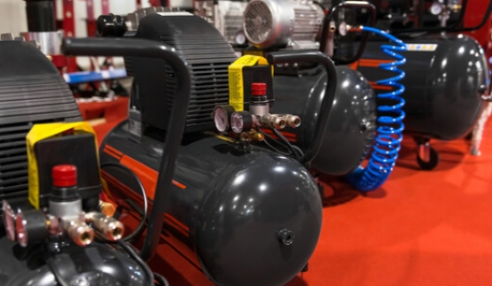

Air compression systems are used in a variety of domestic， commercial and industrial applications. Depending on the intended application， a single-stage or two-stage compressor may be more appropriate. In this article， we will discuss how to distinguish between these two variants， as well as their advantages and uses.

Comparison of single-stage and two-stage compressors

The key difference between a single-stage air compressor and a two-stage unit is the number of stages involved in the compression process.

With a single-stage compressor， the air pulled into its inlet valve is compressed only once and then delivered to a storage unit or directly to the outlet of the intended application. In contrast， a two-stage compressor compresses the air at the inlet in two uninterrupted stages at increasing pressure.

In addition， single-stage compressors are typically used in smaller applications and are usually driven by gas. Two-stage compressors are typically driven by electricity and are useful in larger applications where compressed air is required.

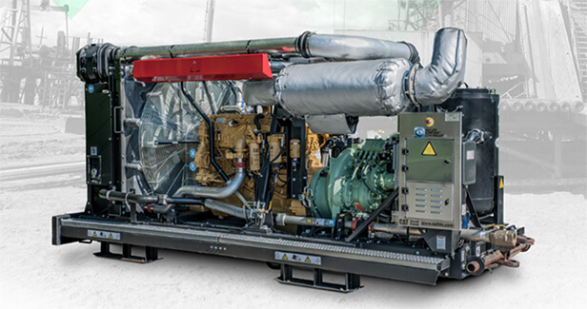

How to determine the number of stages of a compressor block

The easiest way to determine the number of stages in an air compressor package is to check the size of the cylinders and calculate the number of intake ports present. A single-stage compressor will have uniformly sized cylinders， each with its own intake port， while a two-stage compressor will have only one intake valve and non-uniform cylinders.

Single Stage Air Compressors

The following outlines the most important things to know when considering the use of a single stage air compressor.

Uses of Single Stage Compressors

Single-stage compressor equipment is popular in a variety of woodworking and metalworking applications. Some of these uses are described below.

Woodworking Processes

Precise wood cutting， assembly and finishing require power tools to make the process easier， faster and more efficient. Air-powered saws， nailers， drills and sanders are effective options for those involved in woodworking.

Metalworking

Most of the equipment， machines and devices we use on a daily basis contain metal parts. Because metal has a higher tensile strength than other non-metals， manufacturing these parts requires specialized tools to cut， shape and assemble them. Pneumatic compressors play a key role in shaping metal into the various configurations required for different applications.

Advantages of single-stage compressors

The main advantages of single-stage compressors are highlighted below

Single-stage compressor sets are cheaper than two-stage compressor sets

Lighter weight for easier operation by a single staff

Electric models are energy efficient

Two-stage air compressors

The main uses and advantages of two-stage air compressors are highlighted below.

Uses of two-stage compressors

Two-stage compressors are well suited for a variety of industrial-scale applications， including automotive assembly/repair， aerospace engineering， and food and beverage manufacturing.

Automotive Assembly/Repair

In automotive manufacturing plants， two-stage air compressors can drive a variety of production stages， including lifting multiple vehicle components， including engine blocks， frames and housings. Other uses include screw and bolt fastening， lubrication/lubrication， and paint finishing.

Aerospace Engineering Applications

Two-stage pneumatic compressors are virtually indispensable in aerospace engineering. These powerful air compressors are integrated into different stages of aircraft manufacturing， including component forging， cutting， machining， shaping， assembly， fastening， and finishing.

Food and Beverage Manufacturing

In addition to locally sourced fresh fruit and food products， much of the food consumed worldwide is prepared and packaged in large quantities in factories. Commercial food and beverage preparation typically requires two-stage air compressors to drive a variety of processes， including the following.

Blending

Chopping

Frosting

Filling

Sealing

Labeling

Packaging

Discover the nitrogen generators for food packaging.

Benefits of two-stage compressors

Key benefits of two-stage compressors include

Higher cubic value of compressed air compared to single-stage units， resulting in increased efficiency

Operates at a lower temperature， generating less heat in daily operation

Ideal for large scale applications

How many compressor stages do I need?

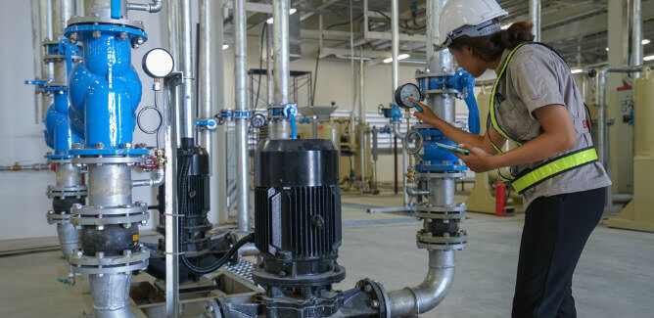

The number of compressor stages required will vary from application to application. For smaller scale single job jobs， a single stage compressor will perform well. However， for industrial scale manufacturing， then a two-stage air compressor is a more appropriate choice.