**Complete Guide to Air Compressor Repair**

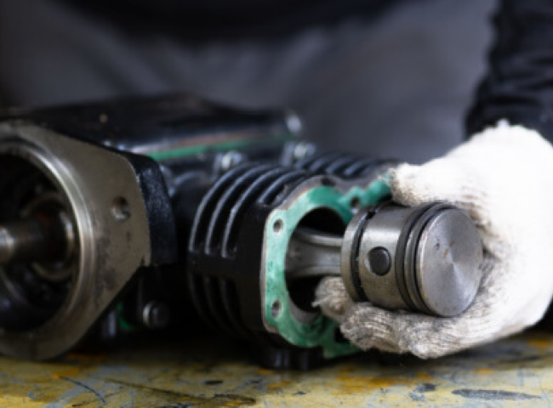

Operators have the option to replace or repair air compressors to significantly reduce downtime and costs associated with failures. However， the choice depends on several factors， including repair history， reliability， repair/replacement costs and energy efficiency. In addition， operators can fix minor problems in-house and leave more complex issues to professionals for repair. This article highlights some considerations for air compressor repair and replacement and presents some common compressor repair guidelines.

Air Compressor Repair and Replacement

In some industrial applications， compressed air is critical to daily operations. As a result， downtime caused by air compressor failure is not good for operators because of lost production， increased costs and reduced overall business efficiency.

Operators must choose between repairing or replacing their compressors to mitigate these adverse effects. However， several factors determine their choice， including the age of the compressor， energy efficiency， maintenance history， overall reliability， and ultimately the cost of repair/replacement.

Factors to Consider

In addition， if the current compressor is relatively new and has been in operation for a short period of time， operators may prioritize compressor repair over replacement. Operators will also consider newer technology when deciding to repair or replace: if a newer air compressor model exhibits similar qualities to the damaged compressor， operators may choose to repair it.

Another consideration includes the availability of spare parts for the repair. If spare parts are readily available， repairs are more feasible and less time-consuming. Finally， the overall reliability of the compressor is an important factor， indicating the potential frequency of failure. For reliable air compressors， repair is a better option than direct replacement.

On the other hand， if the operator experiences a high number of failures， which indicates future failures， then replacing the air compressor may be a better option. In addition， the overall energy efficiency of a newer compressor model may inform an operator's choice to replace， as the new equipment can offset the purchase cost through power savings.

In addition， in the event that spare parts are not available， replacing the compressor appears to be a more viable option. Finally， after considering an organization's current needs， it may become ideal for an operator to replace a faulty compressor with a larger unit to meet increased organizational demand.

Therefore， replacing or repairing an air compressor package is a viable option for an organization. However， operators must incorporate several relevant considerations into their choice. While purchasing a new compressor may initially seem expensive， the cost savings due to reduced maintenance， increased reliability and high efficiency will result in a shorter payback time. Nonetheless， air compressor maintenance may be more feasible in situations where it is prevalent.

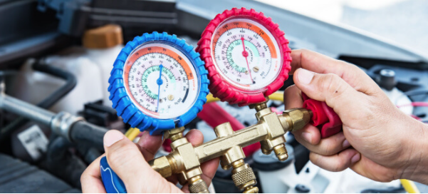

Common Air Compressor Repairs

Air compressors fail or break down when they fail to meet three main requirements: adequate power， pressure maintenance and proper airflow control. Prolonged failure to service the equipment may result in an explosion.

While it is good practice to contract with a professional to perform complex repairs， operators can also perform common air compressor repairs. This includes repairing leaks， replacing unloading valves， adjusting airflow， restoring power， repairing electrical problems， and replacing damaged intake filters.

Repairing leaks

To repair a leak in the unit， the operator must first disconnect each adjacent tool and hose， then start the air compressor booster and allow the pressure to build up. Next， the operator can apply a soapy water solution around each fitting after fully pressurizing the unit. Joints with leaks will form bubbles， which indicate the need for repair.

The operator can then depressurize the compressor and secure each leaking fitting with enough Teflon tape. In addition， the operator must repeat the entire process to confirm if there are any more leaks.

Replacing the Unloader Valve

Some failures require replacement parts to repair. For example， a faulty unloader valve can cause air to trap on the piston， causing the breaker to trip on start-up. The operator can fix this problem by inspecting the valve， cleaning it， and eventually replacing it with a new one， especially if the fault persists.

Adjusting the airflow

This type of air compressor repair depends primarily on adjusting the screws under the pressure retaining valve. The top and bottom screws turn the compressor off and on respectively. Adjusting the airflow involves turning the compressor on and off and using an additional upper screw to control the pressure. The operator can adjust the pressure of the compressor by tightening or loosening the upper screw and adjust the airflow accordingly to obtain the desired pressure.

Restoring Power

Several considerations for restoring power to the compressor unit include: completely plugging the compressor， making sure the switch is on， resetting the system， the condition of the power supply， and the availability of extension equipment. In addition， if everything is in order， the operator must take the unit to a technician for professional repair.

Repairing Electrical Problems

Air compressors can consistently blow fuses and circuit breakers. To mitigate this problem， the operator must replace the use of the extension with a direct connection to the power supply. In addition， loose capacitor wires and other forms of wear and tear on old motors in the equipment can blow fuses and circuit breakers. Therefore， operators must identify failures caused by old motors and replace them when needed.

Replacing Broken Intake Filters

As with the unloader valve， the operator must replace a broken intake filter due to its importance to the entire unit. Since intake filters protrude from the compressor， they can easily be damaged. The operator must find a filter with similar threads and inlet size and diameter to replace a damaged filter in the system.