**What is nitrogen purge and how does it work?**

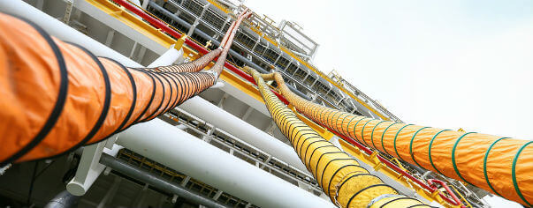

In many industrial processes， maintaining a moisture-sensitive and oxygen-deficient environment is critical to ensuring that the quality of the final product is not compromised. Potential damage from water vapor and oxidation is a common challenge for many industrial manufacturers.

To address these concerns， nitrogen purging is routinely incorporated into relevant processes.

What is nitrogen purging?

Nitrogen purging is a process that removes undesirable or hazardous substances from a system or vessel by replacing the existing atmosphere with nitrogen. This technique is particularly common in industries such as oil and gas， electronics manufacturing and food packaging.

The main purposes of nitrogen purging include

Inerting: Nitrogen is an inert gas， which means it does not react with other substances. With nitrogen purging， oxygen and other reactive gases are displaced， reducing the risk of combustion or oxidation in certain environments.

Oxygen Removal: In oxygen-sensitive processes or storage， nitrogen purging helps to remove oxygen and prevent corrosion， degradation or unwanted chemical reactions.

Moisture Control: Nitrogen is dry， and using a nitrogen purge can help control moisture and minimize the potential for rust， mold or other moisture-related problems.

Contaminant Removal: Using nitrogen instead of atmosphere flushes away unwanted contaminants or impurities， ensuring a clean and controlled environment.

The process involves introducing nitrogen into a system or vessel， gradually replacing the existing air or gas. The displaced air is usually vented， leaving a nitrogen-rich environment. In a variety of industrial applications， nitrogen purging is an important technique for improving safety， maintaining product quality and sustaining optimal conditions.

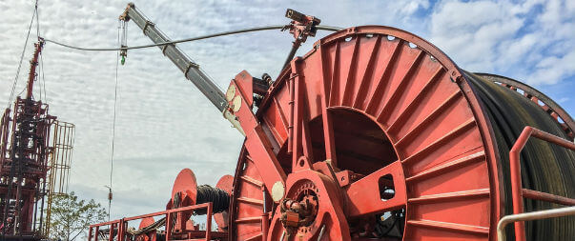

Why Nitrogen Purging is Necessary

The benefits of nitrogen purging are many， but the most important reason for nitrogen purging is to prevent chemical changes in products， as well as to prevent moisture-related equipment damage or even combustion.

Many industrial manufacturing processes are adversely affected if moisture or oxygen-rich air is present. Oxidative damage caused by these unwanted impurities can reduce the quality of the final product and have a costly impact on profitability. Oxygen-sensitive operations require integrated nitrogen purge equipment to prevent unfavorable production conditions.

Common applications for nitrogen purge systems

Nitrogen purging is now used in a wide variety of industrial manufacturing processes， and purging is one of the reasons why nitrogen is so commonly used in industry. Outlined below are some of the main uses of nitrogen purge programs in different applications.

Nitrogen flushing for ships， tankers and potentially flammable environments

Headspace flushing in breweries to extend beer shelf life

Nitrogen purging of transformers and volatile electrical environments

Organic compound purging in the chemical/petrochemical industry

Pipe drying and purging to limit oxygen concentration

Elimination of toxic gases in process chambers (e.g. sputtering tools)

Food-grade nitrogen for aerosol packaging in food production and packaging plants to remove moisture， oxygen and other gaseous impurities

Metal fabrication， using nitrogen purge systems to eliminate compounds that can affect weld quality

Four Types of Nitrogen Purging Systems

There are many types of nitrogen purge systems， and the choice depends on the specific needs of the operation.

There are four main types of nitrogen purge systems:

Nitrogen displacement purging: for equipment with a direct cross-section， such as piping. The process involves the use of a cleaning assembly known as a "pig" that utilizes pressurized nitrogen to push the pig through the internal cavities of the equipment. This purifies the interior and removes gases and particulate contaminants.

Nitrogen Dilution Purification: This involves mixing gaseous nitrogen with the gas to be removed and then discharging the mixture through an exit point away from the gas inlet. Effective for both simple and complex systems such as kilns， reactors and towers.

Pressurized Liquid Transfer: This method is suitable for systems where space is limited and does not require an external pump for liquid transfer. Pressurized nitrogen drives the liquid movement， pressurizing the headspace and purging the vessel. This minimizes the risk of oxidation during liquid transfer between two process tanks.

Holding Vacuum Method: This method is suitable for equipment with only one vent port， where the vessel is pressurized with nitrogen. The liquid in the vessel combines with the pressurized nitrogen and is diluted and vented. The process is repeated as necessary to achieve a satisfactory level of purification.

Nitrogen Purging of Pipelines

Purging a pipeline with nitrogen is an important part of natural gas pipeline commissioning. This procedure is necessary to eliminate oxygen， water vapor， and other impurities that remain in the newly laid pipeline network. Failure to eliminate these substances can alter the quality of the fluid flowing through the pipeline.

Nitrogen purging is a very simple process in which pressurized gas is passed through the inner lumen of the selected pipeline to remove all gaseous and particulate impurities.

Pipe Blowing Safety Tips

N2 purging in an industrial environment has inherent risks. To ensure that pipeline purging is carried out safely， the operator should follow these concise steps:

Ensure that instruments/equipment are handled meticulously

Properly train and brief all personnel on how to safely perform their duties

Specify emergency protocols for shutdown and personnel evacuation， and provide multiple exits