**Nitrogen use in the pesticide industry**

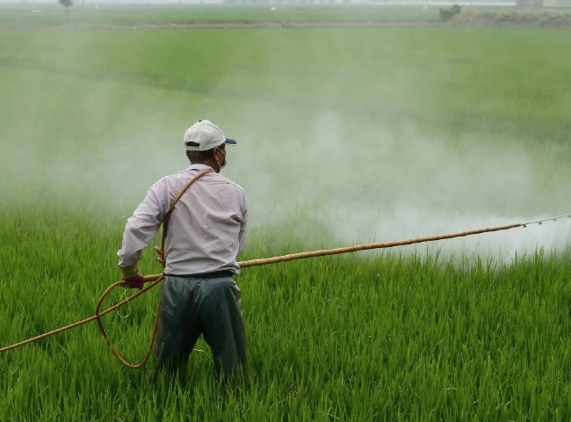

The pesticide manufacturing process is a complex set of multiple sub-processes.

From raw material preparation to the final packaging and shipping stages， multiple processes are in play and several different logistics points are used to handle in-process materials within the same facility or even within multiple semi-finished facilities.

While each industry may have slightly different processes， we can narrow down the pesticide manufacturing process to two broad steps - (a) the technical-level pesticide manufacturing process and (b) the formulation process for the production and shipment of the final product.

In the active ingredient manufacturing process， various organic and inorganic raw materials are processed in a reactor and passed through a fractionation column to make an active technical grade pesticide ready for shipment. There are further steps， including drying and packaging.

In order to improve the transport， handling and dispersion of the pesticide， the active ingredient must be formulated into a final use product. During the formulation of the final product， the active ingredient is pulverized into a fine powder in a mill. The fine powder of the active ingredient is thoroughly mixed with the base solvent and other ingredients. The final product can be dry or liquid and packaged in boxes and bottles， respectively， accordingly.

The use of inert gases is required in many steps that require moving raw materials， covering grinding containers， etc.， to prevent oxidation of many sensitive and volatile chemicals. In such cases， nitrogen is often used as the gas of choice. Nitrogen is easy and cost-effective to produce on site， making it an ideal choice for inert media. Nitrogen is used as a carrier where pneumatic movement of ingredients or raw materials is required. Inter-process storage tanks may be required to store semi-finished products during the preparation process. In the case of volatile chemicals or chemicals that are prone to deterioration due to exposure to oxygen， are kept in nitrogen purged tanks， which are then continuously covered with nitrogen to exclude oxygen from entering the tanks further.

Another interesting use of nitrogen is in the packaging of active ingredients or final products where exposure to oxygen is harmful and can not only cause premature spoilage of the final product， but also significantly reduce the shelf life of the product. In the case of insecticides， an interesting phenomenon is the collapse of the bottle， where air is left in the headspace of the bottle， causing an undesirable reaction inside and causing a vacuum in the bottle， which can lead to bottle deformation. For this reason， many manufacturers choose to purge the bottles with nitrogen prior to filling the insecticide to avoid air in the bottle and to top off the bottle headspace with nitrogen prior to sealing to avoid any air remaining in the bottle.