**What is a compressed air dryer system? - Inline Air Dryer**

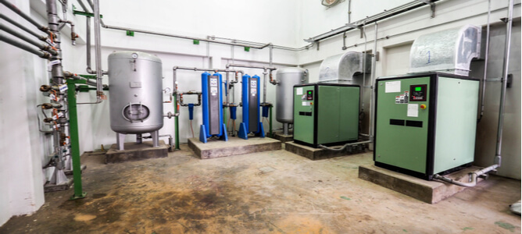

Dry air compressors are essential for a variety of industrial and residential applications. As a result， operators rely on compressed air dryers for optimal operation. This article reveals how these systems fully create functional dry compressed air.

What is a compressed air dryer system?

Compressed air always contains water vapor and other moisture that is harmful to your tools， piping and equipment. They can lead to corrosion， control failures， and ultimately equipment failure. In-line air dryers remove water vapor and moisture content from compressed air before it enters moisture-sensitive components and processes.

How do air dryers work?

Each of these compressed air dryer types has a principle of operation. However， the general function of each is to remove most or all of the water vapor content from the compressed air. The resulting dew point of the compressed air is used as a measure of how dry the air is: the lower the dew point， the lower the moisture content， and vice versa.

This article will explore the various types of compressor air dryers and how they work.

Advantages of compressed air dryers

The use of in-line air dryers has its benefits. They include

Extending the life of piping， tools and equipment

Prevention of equipment corrosion

Effective removal of particles， water vapor and other moisture content from compressed air

Save on equipment maintenance costs

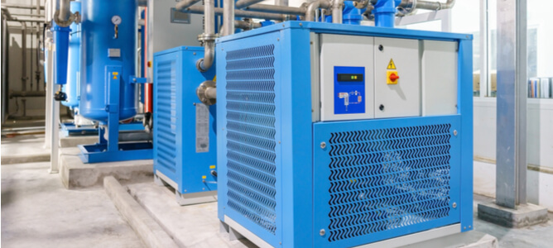

4 Main Types of Compressed Air Dryers

The following outlines the four main types of compressed air dryers that can be used for most industrial applications.

Desiccant Dryers

Refrigerated Dryers

Membrane Dryers

Chemical dryers

1. Desiccant Dryers

Desiccant type air dryers work by adsorbing moisture from the compressed air stream onto desiccant materials. These materials are placed in compartments and effective drying occurs by pushing compressed air through them.

There are two types of desiccant air dryers: heated and non-thermal regenerative. Each type has two compartments: a drying tower for adsorbed desiccant and a regeneration tower， which helps to remove the moisture adsorbed in the desiccant. However， the heat source makes them different: the former requires an external heat source， while the latter does not.

They can achieve moisture removal rates of up to 99.99%. This high efficacy makes them ideal for critical applications. However， they are more likely to have higher acquisition， operation and maintenance costs.

Contact our team today to purchase a compressed air dryer or get a quote for desiccant air dryer procurement!

2. Refrigerated Dryers

The operating principle of a refrigerated air dryer involves causing water vapor to condense by cooling compressed air. The system then collects this condensed water vapor with an internal moisture separator and feeds it to the drain. Air compressor dryers achieve this cooling with the help of a liquid refrigerant.

Some industry participants know the high efficiency and low purchase and maintenance costs of refrigerated compressed air dryers. In addition， they can remove more than 75% of the water content of the air and are acceptable for general air compression applications.

3. Membrane Dryers

How does this type of air dryer work? The working principle of a membrane air dryer involves compressed air being pushed through a membrane tube that collects and holds water vapor. A small portion of the resulting dry air is then used to get rid of the trapped water vapor in the tube.

The membrane dryer can lower the dew point of compressed air to -40°C without lowering its temperature. In addition to effectively removing most of the moisture content， they filter unwanted particles. In addition， they require very little space and consume zero power.

4. Chemical dryers

Chemical dryers use chemicals such as calcium chloride and lithium chloride to strip the water vapor content from compressed air. They achieve a dew point of 15°C by allowing compressed air to pass through these chemical beds， which are already saturated with water. A high-efficiency coalescing filter is typically installed upstream of the air compressor drier to prevent damage. Particle removal filters are installed downstream to avoid output of compressed air containing chemicals.

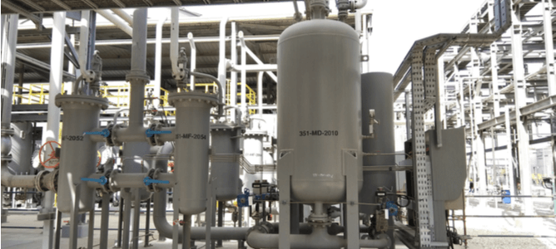

Applications of compressed air dryers

The best compressed air dryers are often used in the following industrial and commercial applications

Material Manufacturing

Material manufacturing operations like pneumatic equipment power， lathe chucking operations， pressure washing of mechanical parts and part cooling often require dry compressed air to ensure and maintain an optimized manufacturing environment.

Learn more about compressed air and the N2 manufacturing process.

Oil and Gas Recovery

Many compressed air dryer types have applications in the oil and gas industry. Some of these include

Drive pneumatic systems

High pressure enhanced oil recovery

Oil and gas transportation

Drilling rig control operations

Most of these applications can be made hazardous by compressed air containing moisture. Therefore， it is important that operators effectively remove this water vapor content to ensure safe operation.

Pharmaceutical Industry

Compressed air that is free of water vapor and moisture is critical to the operation of the pharmaceutical industry. Every process of tablet manufacturing， fermentation， instrument air drying， drug drying and packaging requires dry compressed air. In addition， the air must be free of moisture to prevent contamination. For this reason， compressed air quality testing is also common in the pharmaceutical industry.

Fabric Synthesis

The textile production industry requires large amounts of compressed air for blowing guns， air knives， lifting with pneumatic systems and for cooling equipment components. Since moisture can damage fabrics， dry compressed air ensures their optimal synthesis.

Anti-mold

Mold formation in the workplace can cause various health hazards and violations of safety regulations. Inline compressed air dryer systems can easily deal with this problem by keeping ambient humidity within levels that limit mold growth.

Food and Beverage Production

The production， packaging and preservation of high quality food and beverages requires dry compressed air. Since air is a prevalent food and beverage contaminant， proper compressed air drying can ensure its safe consumption.

Learn more about the need for compressed air in food packaging.

Residential Applications

Residential heat pumps， rotary dryers， condenser dryers， blowers and cloth dryers also apply air compressor dryers. However， most home applications are typically associated with substance drying or incorporated into the type of equipment that requires air drying.