**Advantages of using medical oxygen concentrators**

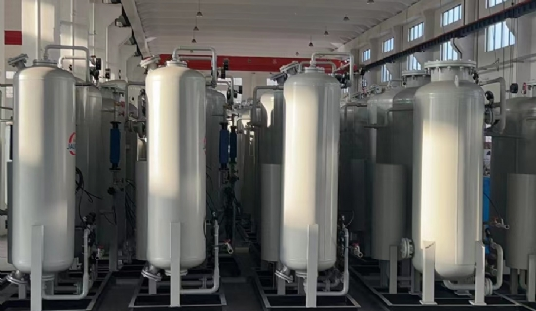

In epidemic situations， hospitals often experience severe shortages of oxygen due to the tremendous demand from many patients. In these times， the limited supply of oxygen cylinders cannot meet the hospital's requirements. They need a steady supply of pure oxygen， which can only be accomplished by medical oxygen generators. XITEch a well-known brand， provides high quality oxygen generators to hospitals large and small.

Advantages of installing on-site oxygen generators in hospitals

Safe to use - the oxygen concentrator is always installed and connected by the manufacturing company. It does not require manual operation as it is fully automated. There is no risk of oxygen leakage from this generator.

Cost-effective - XITE offers oxygen generators at reasonable prices， including installation and annual maintenance costs. It has been found that the cost of owning a medical oxygen generator is only one third of the cost of purchasing an oxygen cylinder for a patient.

Compact size - XITE has created oxygen generators that require only limited space as they measure only 7 feet/9 feet/7 feet. Therefore， hospitals do not need a large space to allow for the installation of oxygen generators on their premises.

Purity of Oxygen - The gas equipment produces oxygen with a purity of 93%-96%. If this purity falls below 90%， the machine stops immediately after sounding an alarm. The purity of the produced oxygen is shown on the display panel of this generator.

● Mass production - The medical oxygen generator produces large quantities of oxygen， depending on the size of the unit. It provides a continuous supply of oxygen directly to the patient's bed through the tubing.