On-site nitrogen generators (PSA nitrogen generators， nitrogen equipment) help in precious metals mining

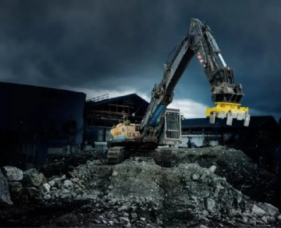
Nitrogen and its application in precious metals mining
The mining of precious metals is a tedious and dangerous task. This work comes with many risks， but with on-site nitrogen equipment， many of these risks can be minimized. The following is a detailed description of the application of nitrogen in the precious metals industry.
Extinguishing fires with nitrogen
Potential fires are a huge threat to the precious metals industry. Not only can they be a danger to miners， but they are also a threat to the environment. When operations have to be shut down due to fires， companies can lose millions of dollars per day. Clearly， having a fast and reliable way to extinguish fires is of the utmost importance to the precious metals industry.
With on-site nitrogen equipment， fires can be extinguished quickly. Fires require oxygen to nourish them， so nitrogen is used to replace oxygen. Once the oxygen is removed from the atmosphere and replaced by nitrogen， the fire will no longer thrive. After the fire has abated， it is often necessary to continue to inject nitrogen for days or weeks to ensure that the fire does not reignite. With an on-site nitrogen generator， you never have to worry about running out of nitrogen. And， because they are so portable， they can be used at remote precious metal mining sites.
Chemically deactivating abandoned areas
Once an area has been cleared out and all the precious metals have been mined， it is the miner's job to keep the area free of any chemicals. This is necessary to prevent explosions and fires. To do this， nitrogen is used. It replaces all the oxygen in the air with nitrogen and then seals the area to prevent oxygen from entering. However， this process is not permanent. Nitrogen needs to be replenished periodically， and having an on-site nitrogen generator (PSA nitrogen machine， nitrogen equipment) makes this easy.
Why use nitrogen generators (PSA nitrogen generators， nitrogen plants) from Hitech Gases?
As you can see， when working with the precious metals industry， having a stable and reliable supply of nitrogen is essential. With an on-site nitrogen generator (PSA nitrogen generator， nitrogen equipment)， companies are able to save time and money while eliminating their reliance on nitrogen cylinders. Nitrogen generators (PSA nitrogen generators， nitrogen equipment) from Hite are very portable and can be delivered quickly in emergency situations.
If you're in the precious metals industry， don't take any chances. Keep a nitrogen generator (PSA nitrogen machine， nitrogen equipment) on site to make sure you have it when you need it. To learn more about our mobile nitrogen generators (PSA nitrogen generators， nitrogen equipment)， contact us today.

