**你需要知道的关于泥蟹的所有信息**

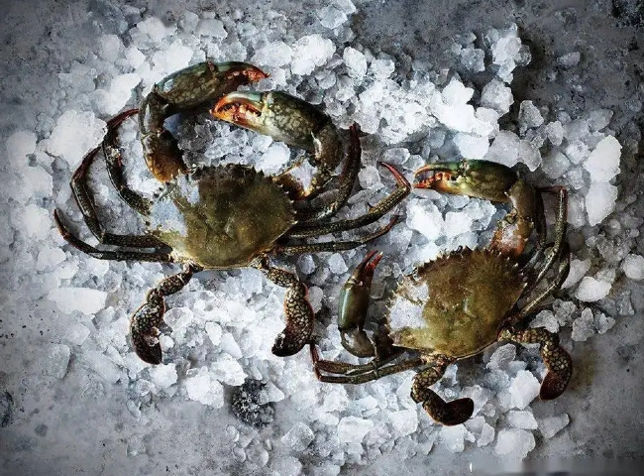

The freshwater mud crab (scientific name: Ilyoplax tansuiensis) is a genus of mud crab in the sand crab family. It is distributed on the island of Taiwan and in Guangdong， Fujian and Zhejiang in mainland China， and lives in seawater， generally on the mudflats of estuaries. It can live attached to wood or other floating objects. There are also a number of species that live in symbiosis with other animals， such as the sheep crab family and the Guan Gong crab family.

Many species such as bean crabs often dive into the coat cavity of some mollusks， or polychaetes in the ducts to co-habit. However， the family of Sancidae lives in the sacs formed by reef-building corals， and the adult female is confined to the sacs for life after mating， and the hatchlings can escape through the small unclosed pores.

Mud crabs have shell lengths up to 24 cm and weigh 2-2.5 kg. At about 9 cm in size， female mud crabs reach sexual maturity. Mud crabs are highly tolerant to nitrate and ammonia. Two types of commercial crabs are available in the market， green mud crabs and red claw crabs. Mud crabs have a smooth and broad carapace. Their claws are used to cut and crush their prey and their hind legs are used for swimming. Mud crabs tend to be dark brown or mottled green in color. Younger crabs feed on zooplankton， mollusks and crustaceans. Older crabs consume polychaetes， gastropod mollusks， and other smaller crabs. Mud crabs are caught using crab cages or pots as bait for meat or fish.

Mud crabs can be killed by placing them in the refrigerator for 2 hours， after which they can be cooked. Mud crabs are cooked in their shells. Once their shells are molted off， they are ready to eat as soft-shell crabs.