**How nitrogen generators can improve the jewelry making process**

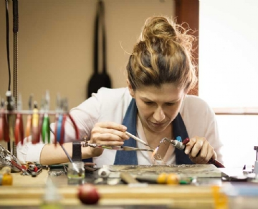

Because of jewelry makers， soldering is required in almost every aspect of their craft， from forming the base for their pieces to adding delicate， ornate details to the final product. However， this process can be hindered by the presence of oxygen in the environment， leading to damage and corrosion of the metals involved. To reduce this risk， many jewelers use nitrogen generators to add nitrogen to their manufacturing process in order to create a barrier between the metal and the environment.

What is soldering?

Soldering is the fusing of two metals together by heat. This heat source usually comes from a blowtorch or other industrial equipment. During the welding process， the manufacturer melts the metal objects and joins them together. A filler metal with a relatively low melting point fills the objects where they meet， forming a permanent joint as the metal cools.

Welding is a delicate and dangerous process. However， it is an important part of a wide range of industries: welding， plumbing， electronics and jewelry manufacturing. Jewelers in particular use this process in their craft to form their artwork. Unlike soldering pipes， the soldering process in jewelry manufacturing requires a light touch for this complex artwork， as jewelers must use very fine materials.

One of the main risks in the jewelry soldering process is the presence of oxygen in the environment. When soldering is done in an oxygen-rich environment， the metal can corrode and the bonding becomes less effective. As a result， the jewelry may fall apart.

Nitrogen generation and jewelry manufacturing

A simple solution to reduce the risk of oxygen corrosion in jewelry manufacturing is to replace oxygen-rich air with nitrogen. In this process， jewelry manufacturers can use nitrogen generators， such as those supplied by Soochert， to store the gas for use in the soldering process. These nitrogen generators separate the nitrogen from the other elements in the air and store the gas in a tank for later use.

Simply put， the nitrogen replaces the oxygen in the air. When soldered materials are needed， jewelers use nitrogen to flush out the environment. This creates a barrier between the metal and the oxygen in the air， reducing the effects of oxidation. Since nitrogen is non-flammable， it is completely safe to work with highly heated materials during the soldering process.