**PSA oxygen generators for all industries**

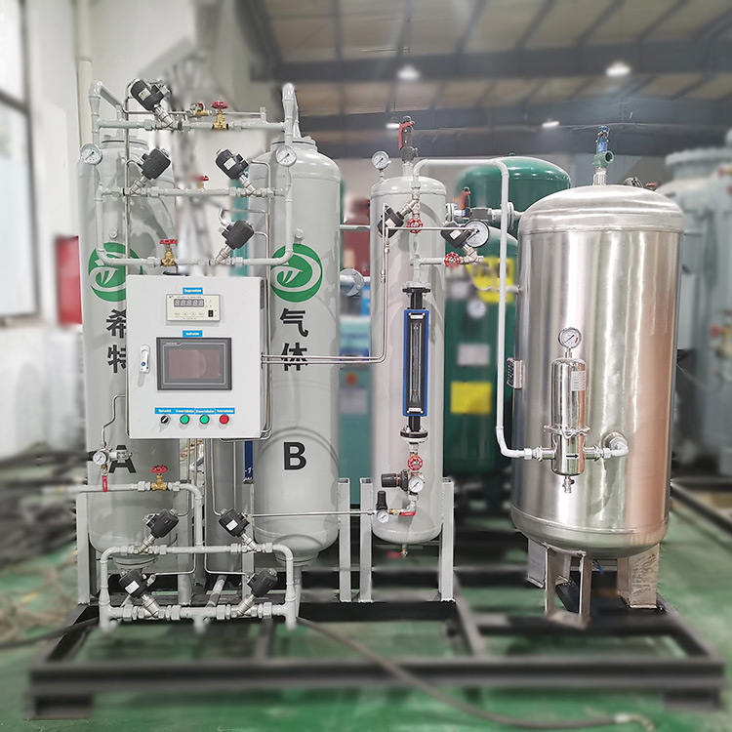

Many industries such as chemical， medical and other industries require oxygen generators to perform a number of production operations. For this reason， most tradesmen and industrialists are looking for high quality oxygen generators for greater efficiency. Today we bring you some tips on choosing a PSA oxygen generator supplier that will help you choose the perfect one for yourself.

Oxygen Concentrator Manufacturers

There are many manufacturers who have set up a dedicated production unit to manufacture and supply oxygen concentrators， but they don't know how to maintain its quality. Perhaps， they do not use quality raw materials， resulting in a poor quality end product. So， if you are planning to buy a unit， be aware of such manufacturers and avoid them.

Here are some quick tips for choosing a top manufacturer.

Check if they are a certified supplier

Check the capacity of their equipment

Check their market reputation and history

Compare the prices of more than two manufacturers to get an accurate estimate of the cost

Prepare a list of features you want in your gas equipment and check with the supplier

Select a supplier

Here I recommend a quick online search of different suppliers， as many of them have their own online presence. Visiting their websites will give you an overview of what they do and what they offer. If you are interested in buying an oxygen concentrator， then an online supplier is preferable to an offline supplier. This is because they provide every detail of their products and you can also compare two or more suppliers and choose the one with the lower price. In addition to this， you can also compare their quality， maintenance costs， operating costs and other features of the equipment.