**Oxygen for patient care and production of covid-19 vaccine**

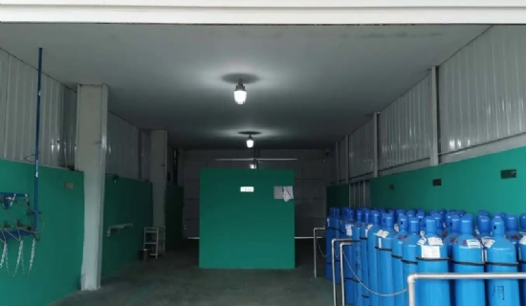

Medical oxygen is playing an important role in the response to the corona crisis. It is used worldwide to treat Covid patients and is now also used to create life-saving vaccines. By producing oxygen on a self-sufficient basis， hospitals and pharmaceutical manufacturers have been able to keep costs down while ensuring supply.

Medical oxygen has been used to ventilate patients around the world since the beginning of the New Covid crisis. The pandemic has led to supply bottlenecks in the existing liquid oxygen supply network in many countries. In order to avoid this in the future， many medical institutions， with the support of their governments and ministries of health， are looking to support oxygen supply through decentralized oxygen production with the help of oxygen generators. This is reflected in a sharp rise in the number of orders， especially from Peru， the UK， China and Arab countries. Medical oxygen is also used for the production of genetic vaccines， live and dead vaccines， and vector vaccines for the fight against SARS-CoV-2. This requires culturing bacteria or cells in a bioreactor with oxygen to be able to manufacture the components of the vaccine on an industrial scale.

On-site oxygen production meets the highest quality standards

The XITE oxygen generator generates oxygen directly from ambient air with the help of PSA technology. The purity of the generated medical oxygen is 93% ± 3%， which meets the European Pharmacopoeia standards for medical applications. The generators are designed according to strict quality management specifications and are certified according to the Medical Device Directive 93/42 / EEC. Our satisfied customers protect themselves from delivery bottlenecks through self-sufficient production， save up to 60% of costs， and protect the environment and climate through environmentally friendly processes.