Nitrogen use in autoclaves

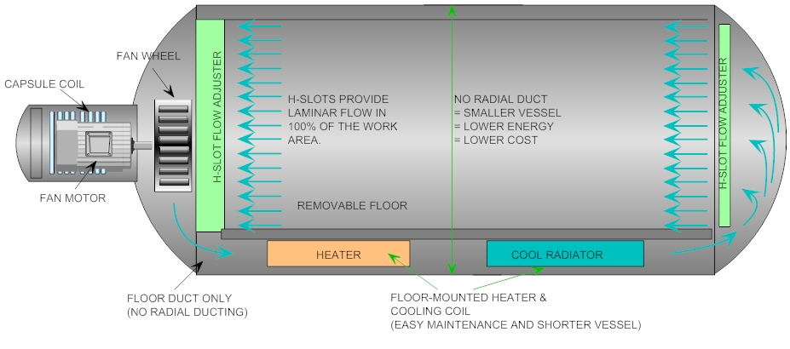
Autoclaves are used today in several industries， such as composite manufacturing and metal heat treatment. An industrial pressure vessel is a heated pressure vessel with a quick-opening door that uses high pressure to process and cure materials. It uses heat and high pressure to cure products or to sterilize machines， equipment and instruments. Several types of pressure vessels are manufactured， such as rubber bonded/vulcanized pressure vessels， composite pressure vessels， and many other types of industrial pressure vessels. Autoclaves are used in several industries to help manufacture polymer composites.
The automated steaming process allows manufacturers to produce the highest quality materials. The heat and pressure in autoclaves are used in a variety of products， helping to improve the overall quality and strength of those products. As a result， the aviation industry uses machines and aircraft capable of handling harsh environments. Autoclave manufacturers can help produce composite autoclaves capable of producing high quality products.
When composite parts are manufactured and cured， the pressure in the autoclave environment puts them into a situation where they become highly flammable due to the increased pressure and temperature inside the autoclave. However， once curing is complete， these parts are safe and the risk of combustion is virtually avoided. During the curing process， these composites may burn if the right conditions are present， i.e.， oxygen is introduced. Nitrogen is used in autoclaves because it is inexpensive and inert， and therefore will not catch fire. Nitrogen safely removes these exhaust gases and reduces the risk of fire in the autoclave.
Depending on the customer's requirements， autoclaves can be pressurized with either air or nitrogen. The industry standard seems to be that air is OK at temperatures around 120 degrees Celsius. Above this temperature， nitrogen is often used to aid heat transfer and reduce the possibility of fire. Fires are not common， but they can cause a lot of damage to the autoclave itself. Damage may include full loads of parts and production downtime while repairs are made. Fires can be caused by bag leaks and local frictional heating caused by exothermic resin systems. At higher pressures， more oxygen is available for the fire. Nitrogen filling should be considered since the entire interior of the pressure vessel must be removed after a fire to inspect and repair the autoclave.
The autoclave system must ensure that the required pressurization rate within the autoclave is met. Modern autoclaves have an average pressurization rate of 2 bar/min. Many autoclaves now use nitrogen rather than air as the pressurization medium. This is because autoclave treatment consumables are highly flammable due to the presence of oxygen in the air medium. There have been several reports of autoclave fires， which always result in the loss of components. Although the nitrogen medium ensures a fire-free autoclave curing cycle， care must be taken to avoid danger to personnel (possible asphyxiation) in a nitrogen environment due to the low oxygen content.

