**Nitrogen in the pharmaceutical industry can save costs in drug production**

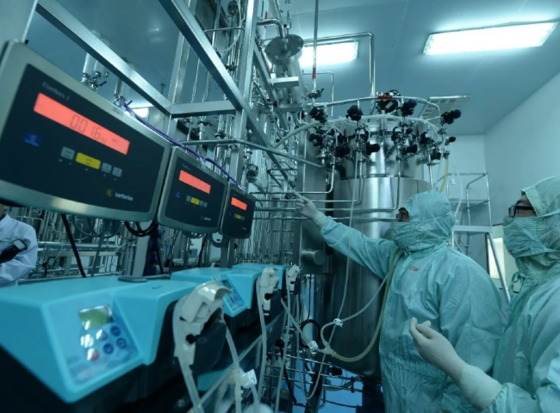

Because of the impact of its end products on human health and the environment， the pharmaceutical industry handles its products with great precision and care. Even a very small mistake can lead to danger. Pharmaceutical manufacturers need to be very precise with their products from manufacturing to packaging and shipping. Oxygen in the atmosphere reacts with the chemicals processed， causing changes in the chemical composition of the drugs produced， which can become a threat to human life and will adversely affect the reputation of the manufacturing company involved in terms of branding and turnover.

Earlier there were several traditional methods， but with the advancement of technology， nitrogen has become a major source for pharmaceutical products with a wide range of applications.

Some of these applications are as follows.

Transferring

Flushing

Blanking

Pharmaceutical manufacturing

Aseptic packaging

Analytical Testing

Filtration， Separation and Purification

Nitrogen plays a vital role in the pharmaceutical industry， with applications ranging from packaging to fire suppression in significantly unstable production environments. Nitrogen generators capable of producing nitrogen on site can now deliver the same purity as liquid nitrogen， helping pharmaceutical manufacturers reduce costs without sacrificing quality or efficiency.

Delivery of liquid nitrogen requires the conversion of the gas to a liquid for trucking. Upon arrival， the liquid must then be converted back to gas. As these fill points are loaded into transport vehicles at the nitrogen facility and unloaded again at the pharmaceutical manufacturing facility， this two-transfer status creates avoidable product waste， not to mention additional delivery costs. Most importantly is the time spent in all of this process， which is even more important.

Nitrogen， when delivered to a pharmaceutical manufacturing facility， must also be stored on site before it can be used， which also results in additional unnecessary waste. Once in a cooled tank， the loss is often 10% of the delivered volume， which is automatic. Also， even with a good vacuum， if the internal pressure is allowed to increase， the tank will lose at least 0.4% of its volume per day as the gas remains stationary. Blowing or releasing the pressure inside the tank would also only result in additional waste.

Consider this: Although it takes a lot of energy to generate liquid nitrogen， about 90% of the end use of nitrogen requires it as a gas rather than a liquid. The primary reason nitrogen is liquefied is for ease of transport， so moving to on-site nitrogen production can help reduce energy costs and lower emissions associated with the day-to-day operations of a facility.

While liquid nitrogen delivery channels have traditionally provided higher product purity， an important factor in pharmaceutical manufacturing， XITE's nitrogen production technology has helped improve the purity of on-site nitrogen generators to bridge this gap. As a result， the high purity of on-site nitrogen production is now comparable to that of liquid products， and with the proper instrumentation， oxygen concentrations can be measured down to the ppm level. Most pharmaceutical industry applications can be met within the 10 to 5 ppm level， which can be easily achieved with the XITE nitrogen generator， XTFD-100.