**Field oxygen generator equipment: module structure， features and advantages**

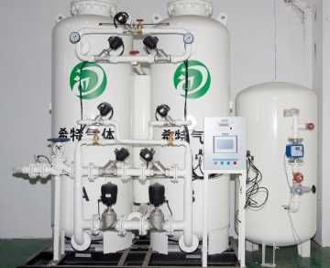

Over the past 10 years， we have been providing the industry with standard oxygen generation systems and self customized designs to provide customers with high-quality oxygen generators. We serve more than 20 countries and provide systems for dozens of industries. XITE equipment is reliable， so it has become an important part of the enterprise's assets in many fields. The oxygen generator we provide to our customers can be used almost anywhere.

Standard oxygen generator

Each of our systems can last for decades， even in the most remote places in the world and under the worst climatic conditions; In addition， our oxygen generation system can be used worldwide because our oxygen generator system is compatible with global power supply.

Customized oxygen generator equipment

After the design process is completed， we will produce the oxygen generator customized according to your requirements to meet your exact needs. After production， the equipment will provide unlimited oxygen supply according to your required flow， pressure and purity.

Pressure swing adsorption (PSA) in oxygen production

Our O2 generator uses pressure swing adsorption as a means of generating oxygen. Adsorption refers to the process of physically separating gas molecules from each other.

Field oxygen generator system layout with purity of 95% and 99%

For 95% purity:

The oxygen system consists of an intake compressor and a dryer， which leads to the air reservoir， then two sieve beds， and finally an oxygen buffer tank.

99% purity:

Like the 95% purity system， there is an intake compressor leading to the dryer， air reservoir， two sieve beds and an oxygen buffer tank; However， behind the oxygen buffer tank is a 99% oxygen generator， which leads to a 99% oxygen buffer tank， then a buffer tank， and finally a booster compressor.

Oxygen is produced by pressure swing adsorption process

Compressed air is used to pressurize the container containing zeolite. Zeolites separate molecules from each other. When air is forced into a container filled with zeolite， oxygen molecules are trapped; However， other molecules can float freely. With the release of pressure， trapped oxygen molecules are collected and used in O2 buffer tank; At the same time， unwanted gas is released back into the air through the pressure relief valve. Once released， these molecules recombine with the ambient air. When the first sieve bed releases nitrogen molecules， the second bed starts the process again. This ensures that you will never run out of oxygen.