**Nitrogen generators for the pharmaceutical industry， covering， transport and packaging**

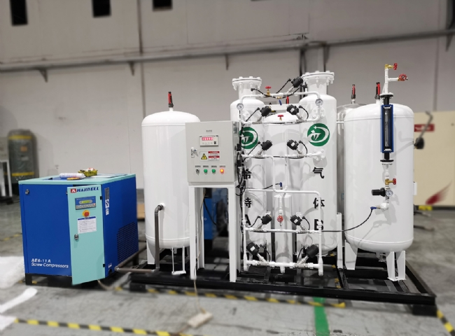

Gas generation， Nitrogen， PSA nitrogen generators

The production and packaging of modern pharmaceuticals would not be possible without industrial gases. In addition， the development of new drugs relies heavily on modern laboratory equipment， for which specialty gases are essential.

In the pharmaceutical industry， potentially oxygen-sensitive materials such as APIs， inactive ingredients and other chemicals need to be stored in an inert atmosphere to prevent exposure to oxygen and subsequent spoilage due to oxidation. In the storage and processing of such oxygen-sensitive materials， nitrogen is used as a filler gas， a purge gas， and also as a gas to move products through pneumatic conveying systems. Nitrogen is often used in the transfer of pharmaceutical products. The use of a safe inert gas for transferring liquid or powdered pharmaceutical materials is necessary because these materials can be hazardous if not handled properly.

Packaging with inert nitrogen

Many pharmaceutical products are packaged in so-called blister packs， where each tablet is individually wrapped between a plastic box and aluminum foil. This packaging is then filled with pharmaceutical-grade nitrogen， which is an inert gas. With such packaging， air does not come into contact with the medication， thus preventing oxidation of the medication.

Handling nitrogen coverings

Filling with nitrogen can also help preserve or improve the quality of pharmaceuticals and other medical products. Covering with nitrogen essentially replaces the oxygen present with nitrogen， so there is little chance of harmful side effects from oxygen. When oxygen is present and reacts with other materials， corrosion， rusting， oxidation and other significant reactions can occur. This can severely alter or damage the product being handled or manufactured. In the pharmaceutical and medical industries， conditions must be maintained for safe handling and manufacturing of products.