**Types of Instrument Air Dryer - Working Principle of Industrial Air Dryer**

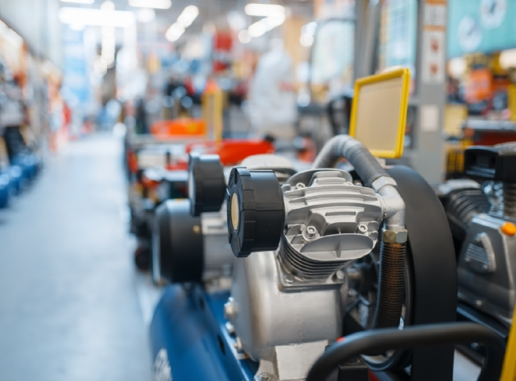

Compressed air is an important tool in industrial and petrochemical processes. It is used to operate critical machinery such as jackhammers， air drills and wrenches， as well as process equipment such as gas cylinders and pumps.

What is the purpose of an industrial air dryer?

An industrial air dryer is a piece of equipment or machine used to dehumidify compressed (process) air to significantly reduce or eliminate the presence of moisture in the air stream. Industrial air dryers can be used to reduce the dew point of compressed air to below the lowest temperature obtained in the field (typically 18°F below the coldest point). Compressed air testing can determine if your equipment is at risk.

The importance of air dehumidification in industrial production

Atmospheric air usually contains a percentage of water vapor， which can create problems in pneumatic equipment and adversely affect the quality of the final product.

Vapors present in the air stream can condense into the compressed air system， causing corrosion， scaling or clogging of orifices and valves. For this reason， dry air is used to dry pipelines after decommissioning and hydrotesting.

The presence of moisture in the process system can reduce lubrication and lead to wear of mechanical moving parts.

Condensed steam can cause freezing of control lines， which can interfere with the operation of controls.

Moisture in compressed air systems can cause industrial metering equipment to give inaccurate readings， which can lead to unnecessary downtime.

Types of Instrument Air Dryers

Now that you understand the importance of utilizing an air dryer for your industrial equipment， learn about common air dryer types for air compressors to help you choose the best option for your needs.

Refrigerated Air Dryers

Refrigerated air dryers are a popular choice for eliminating the presence of water vapor， aerosols and mist in compressed air systems. They can achieve a dew point suitable for most applications and are relatively simple to design， install and maintain.

How Refrigerated Air Dryers Work

Refrigerated air dryers work on the same principle as a household refrigerator or air conditioning unit. The compressed air entering the unit is first cooled in an air-to-air heat exchanger.

The cooling air flowing out pre-cools the incoming hot air， condensing any moisture present into liquid water， which is then discharged from the system. The pre-cooled air then enters an air-refrigerant heat exchanger that uses liquid refrigerant for cooling. The moisture condenses into a liquid state and is discharged from the system.

There are two types of refrigerated air dryers， recirculating and non-circulating.

Recirculating type

Recirculating type dryers use a refrigerant (such as R314A or R407C) to cool a liquid or solid substance around the air inlet of the heat exchanger. The substance can be glycol or a metal block that acts as a heat sink and cools the compressed air. A thermostat is used to regulate the temperature and provide energy savings by shutting off the compressor at partial or zero load.

Non-circulating type

In a non-circulating type air dryer， the refrigerant is continuously circulated through the system without intermittent shutdown. The refrigerant flow is regulated by a bypass valve or unloading valve to match the amount of compressed air entering the system and to maintain a stable operating temperature.

Comparison of circulating and non-circulating air dryers

The main advantage of using a recirculating air dryer is to achieve energy savings at partial and no air flow. The disadvantages are that it has a higher initial capital cost than the non-circulating type， takes up more space (due to the mass of the radiator)， and is prone to dew point fluctuations.

The main benefits of a non-circulating air dryer are continuous compressor operation and a stable dew point. However， there is no local energy savings and no air flow.

Regenerative desiccant air dryer

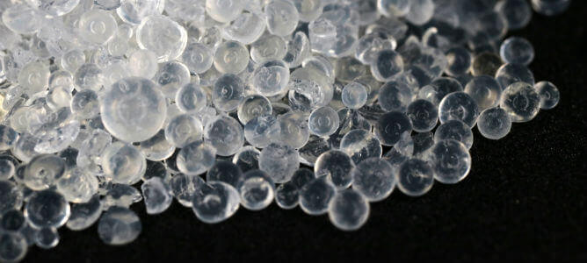

This type of air dryer utilizes two towers - one containing desiccant to remove moisture from the air stream from the compressor， and the other to regenerate the used desiccant after the pressure drops to atmospheric conditions. Similarly， regenerative desiccant dryers are of the heatless， externally heated or compressed heat type.

Working Principle of Heatless Air Dryer

Heatless desiccant air dryers use desiccant in a double tower - one for drying and the other for regeneration. Wet compressed air enters the drying tower and passes through the desiccant， which adsorbs it and discharges it as dry air (with a dew point between -40 and -100 °F). The regeneration tower recovers the desiccant in its pure form. Heatless air dryers do not require internal or external heaters.

To purchase a desiccant air dryer or get a quote for an industrial dryer rental， contact our team today!

How Heated Instrument Air Dryers Work

Heatless type dryers operate using internal/external heaters to generate heat and are arranged in a twin-tower configuration. As with the heatless type， moist air flows into the drying tower and is dried by the desiccant. The second tower regenerates the desiccant.

Some of the dry air leaving the tower passes through the heater and desiccant， thus removing the adsorbed moisture. The moist air is discharged out of the system through a muffler. Heated air dryers can reach a dew point of -40 to -100°F.

Membrane Air Dryers

Membrane dryer systems utilize semi-permeable membrane fibers to separate moisture from compressed air. Membrane systems are a low-cost and eco-friendly alternative to other air dryer types， with the added benefits of space savings and reduced maintenance.

How Membrane Dryers Work

A membrane air dryer consists of a bundle of hollow fiber membranes with specific porosity， housed in a hollow cylindrical vessel. Wet compressed air introduced through the inlet flows through the cylinder and the pressure difference inside the tube allows water molecules to pass through the membrane pores， while the dry air flows through the outlet. The efficiency of a membrane air dryer depends on the membrane selectivity， which depends on the pore size.