**Supply of nitrogen inert gas plants for large cement companies**

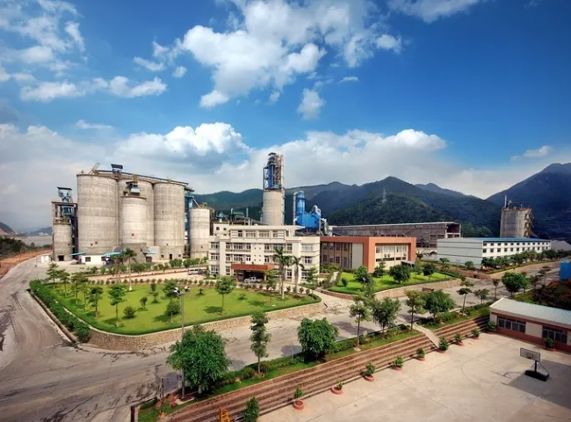

PSA nitrogen generator， nitrogen generator， nitrogen gas

Suzhou XITE is a turnkey designer， manufacturer and supplier of nitrogen booster for coal mills. Our system consists of a nitrogen generator system， a nitrogen storage system and a nitrogen booster system. Nitrogen is used for cleaning of coal mills， bag filters and coal bunkers to control fires due to spontaneous combustion of pulverized coal.

Combustion is a high temperature exothermic redox chemical reaction between fuel and oxidizer， which means that combustion requires oxygen， fuel and heat. We also know that the limiting oxygen concentration (LOC)， also known as the minimum oxygen concentration (MOC)， is defined as the limiting concentration of oxygen below which combustion is not possible.

 According to the flammability diagram， we can find the limiting oxygen concentration for certain processes. By limiting the oxygen concentration we can control the combustion and by inerting the nitrogen we can control the limiting oxygen concentration and thus reduce the possibility of combustion.

The above principles are used to design nitrogen inerting systems (inerting systems) for coal mills， silos and bag filters in cement industry production Suzhou XITE designers， manufacturers and suppliers of complete nitrogen inerting systems include the following items

Nitrogen generation systems

Nitrogen storage systems

Nitrogen booster systems