**Oxygen generators: How companies can benefit from oxygen generators**

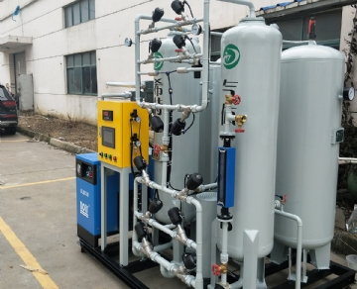

Oxygen generators are valuable to businesses in a variety of industries. Oxygen is vital in many functions that support life and basic chemical reactions. Whether you are looking to change your oxygen supplier soon or are in the market for an oxygen generator， it's good to educate yourself on the many benefits of oxygen generator systems in the business world. Let's take a look.

Benefits of Oxygen Generator Machines Explained

Oxygen has sustained human life on earth for countless millennia. This essential gas is also helpful in hospitals， welding facilities， aerospace and many other industries. Today's oxygen generator systems are safer in regulating oxygen production than other current oxygen supply methods. Their noteworthy applications include fish farms， welding， research laboratories， veterinary and medical life support.On Site Gas produces high quality oxygen generators to provide you with oxygen at those critical times.

In welding and metalworking， oxygen raises the temperature of the welder's flame， making it useful in precisely cutting steel and other metal alloys. While operating an oxygen-powered flame requires skill， its use is beneficial and sometimes required in specific applications. It can also melt metal in a more localized area than other types of gases.

In zoos and aquariums， oxygen plays a vital role in aquarium husbandry and veterinary medical life support， as many animals have needs. The supply of oxygen is fast and efficient， minimizing any risk to the animals.

Many research institutions use oxygen generators daily in their work， including biochemists， universities， government science departments and more. According to ongoing research， generators in this environment need to operate reliably to maintain a safe working environment.

In the gold and silver mining industries， gold production can be more than doubled over standard or gravity separation and concentration using oxygen to convert mineral sulfides to sulfate and process them. Oxygen is safer and more productive， effectively reducing liability and increasing profits at the same time. High purity oxygen can be delivered directly to the job site via portable oxygen generators.

Last but not least， oxygen is best known for providing life support in a variety of medical applications. Therefore， oxygen generators need to deliver gas continuously and reliably. It is an essential tool for hospitals， inpatient services， hospices， urgent care facilities and ambulances. Portable generators are particularly useful in these situations.