**Tips for using multifunctional control valves**

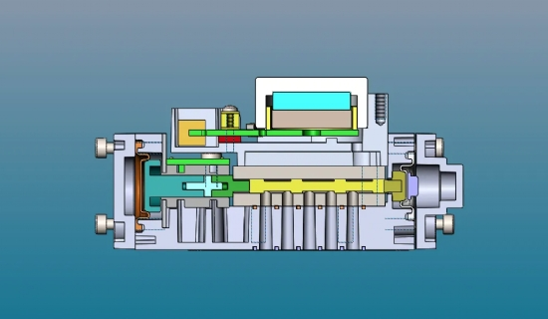

Multifunctional control valve use tips.

1， the valve is to the pipeline itself medium pressure as a power source， opening and closing， adjustment， the pilot valve and the system of small pipeline different combinations， it can have nearly 30 kinds of functions， now gradually get more common use.?

2， pilot valves rely on the water level and pressure changes as the object of control and action， due to the many types of pilot valves， can be used alone or several combinations of use， you can make the main valve to obtain the water level and water pressure and flow rate， etc. for individual or composite adjustment function. But the main valve is similar to the shut-off valve， the valve is fully open， its pressure loss is much larger than other valves， and the more each opening loss coefficient is close to fully closed， the more dramatic， the larger the valve diameter is more significant.?

3， with the above characteristics of the valve， in close to fully closed， the action of the valve flap accelerates， prone to water hammer (water impact pressure)， close to fully closed， the slower the valve action， the better， so the throttling mechanism can be set on the valve flap.

4， in addition to the throttling and action part of the pilot valve to try to avoid setting a particularly small diameter orifice， so as not to block. If necessary， add a strainer， regular maintenance and set up bypass piping. This valve development， the use of promising prospects.