**Manufacturing and N2 technology**

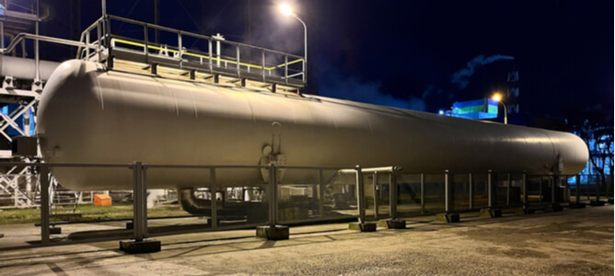

Nitrogen is one of nature's most valuable and abundant chemical substances. In its gaseous state， nitrogen is almost indispensable in modern manufacturing applications. This article will highlight the role of nitrogen in some of today's most critical product industries.

Why is nitrogen important to manufacturing processes?

Gaseous nitrogen has a number of beneficial physical and chemical properties that make it a popular choice for manufacturing. Nitrogen exists in nature as a very stable diatomic molecule. It can be used to replace more reactive chemical elements and compounds. As a result， this gas is common in industries with highly explosive environments.

Another key distinguishing feature is its lack of odour. This physical property is desirable in food and beverage processing as the original food and beverage flavours are not altered. The colourless nature of food grade nitrogen also benefits operators who use nitrogen in their applications. For example， nitrogen is more suitable for modified atmosphere packaging of food products as it does not alter their appearance.

How is nitrogen produced for manufacturing?

Nitrogen used in industrial manufacturing is utilised through different techniques. In many cases， large quantities of gaseous nitrogen are synthesised on site by one of the following methods

Variable Pressure Adsorption (PSA)

PSA nitrogen technology operates by selectively separating nitrogen from air. A typical variable pressure adsorption unit consists of two drying cylinders containing molecular sieve material， alternating between the adsorption and release of oxygen. The result is the generation of high purity nitrogen.

Membrane nitrogen generation

For industrial systems using membrane nitrogen as a gas source， this technology uses the velocity difference between the various air components to generate a stream of pure nitrogen. A semi-permeable membrane with hollow fibres will selectively filter out gaseous nitrogen from the gas mixture.

Fractional distillation

Fractional distillation produces very high purity (99.999%) nitrogen by cooling the air to its liquefaction point and then distilling it according to the boiling point of its constituent gases.

How is nitrogen technology used in manufacturing?

Nitrogen technology is currently used in a number of manufacturing processes in different industries. The following is an overview of some of the common industries that utilise nitrogen technology.

Metal manufacturing

The metallurgical industry requires the production of high quality metal parts for the assembly of various machines， and nitrogen plays a key role in this process. On-site nitrogen generators can be used to produce sufficient quantities of nitrogen for use in metal cutting lasers， effectively producing metal parts with neat edges without causing excessive heat damage.

Pharmaceutical manufacturing

Molecular nitrogen is an almost indispensable chemical substrate for the synthesis of many of the life-saving drugs we use today. Nitrogen generators are used to produce synthetic antibiotics and anaesthetics.

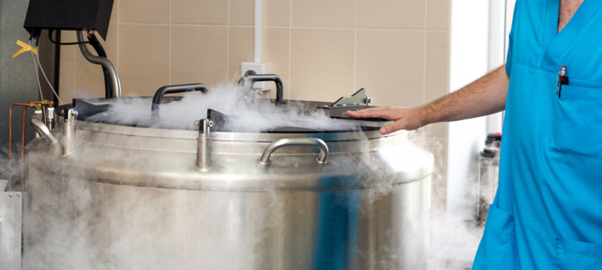

Food and beverage manufacturing

Extending the shelf life of commercially produced food products can be achieved by using gaseous nitrogen at the processing stage. Modified atmosphere packaging using nitrogen creates an environment within the food package that inhibits rapid oxidative deterioration.

Alcoholic beverages require careful processing to achieve a satisfactory flavour and aroma. For this reason， nitrogen is often used to refill wines and to make high-quality nitrogenated beer.



Plastics manufacturing

Nitrogen technology is also used in the plastics and synthetic polymer industries to improve the end product. For example， nitrogen can harden plastics， improving their tensile strength and durability.

Electronics manufacturing

Modern electronics are made up of electrical circuits in which the various components are held together by soldering. Nitrogen soldering is a very effective method of assembling electronic components， as it guarantees an excellent finish. In addition， nitrogen cools computer systems and prevents heat-related damage.

On-site nitrogen and batch supply methods

Nitrogen used in industrial applications can be supplied in cylinders by gas suppliers or generated on site using nitrogen generators. On-site synthesis of nitrogen offers significant advantages over bulk supplied gases.

Long term cost effectiveness as the cost of recurring cylinder purchases is eliminated.

Reduced waste as only the required amount of nitrogen is generated and used for production

elimination of occupational health hazards associated with cylinder storage

Elimination of supply chain blockages as nitrogen can be generated on demand at any point in the production cycle